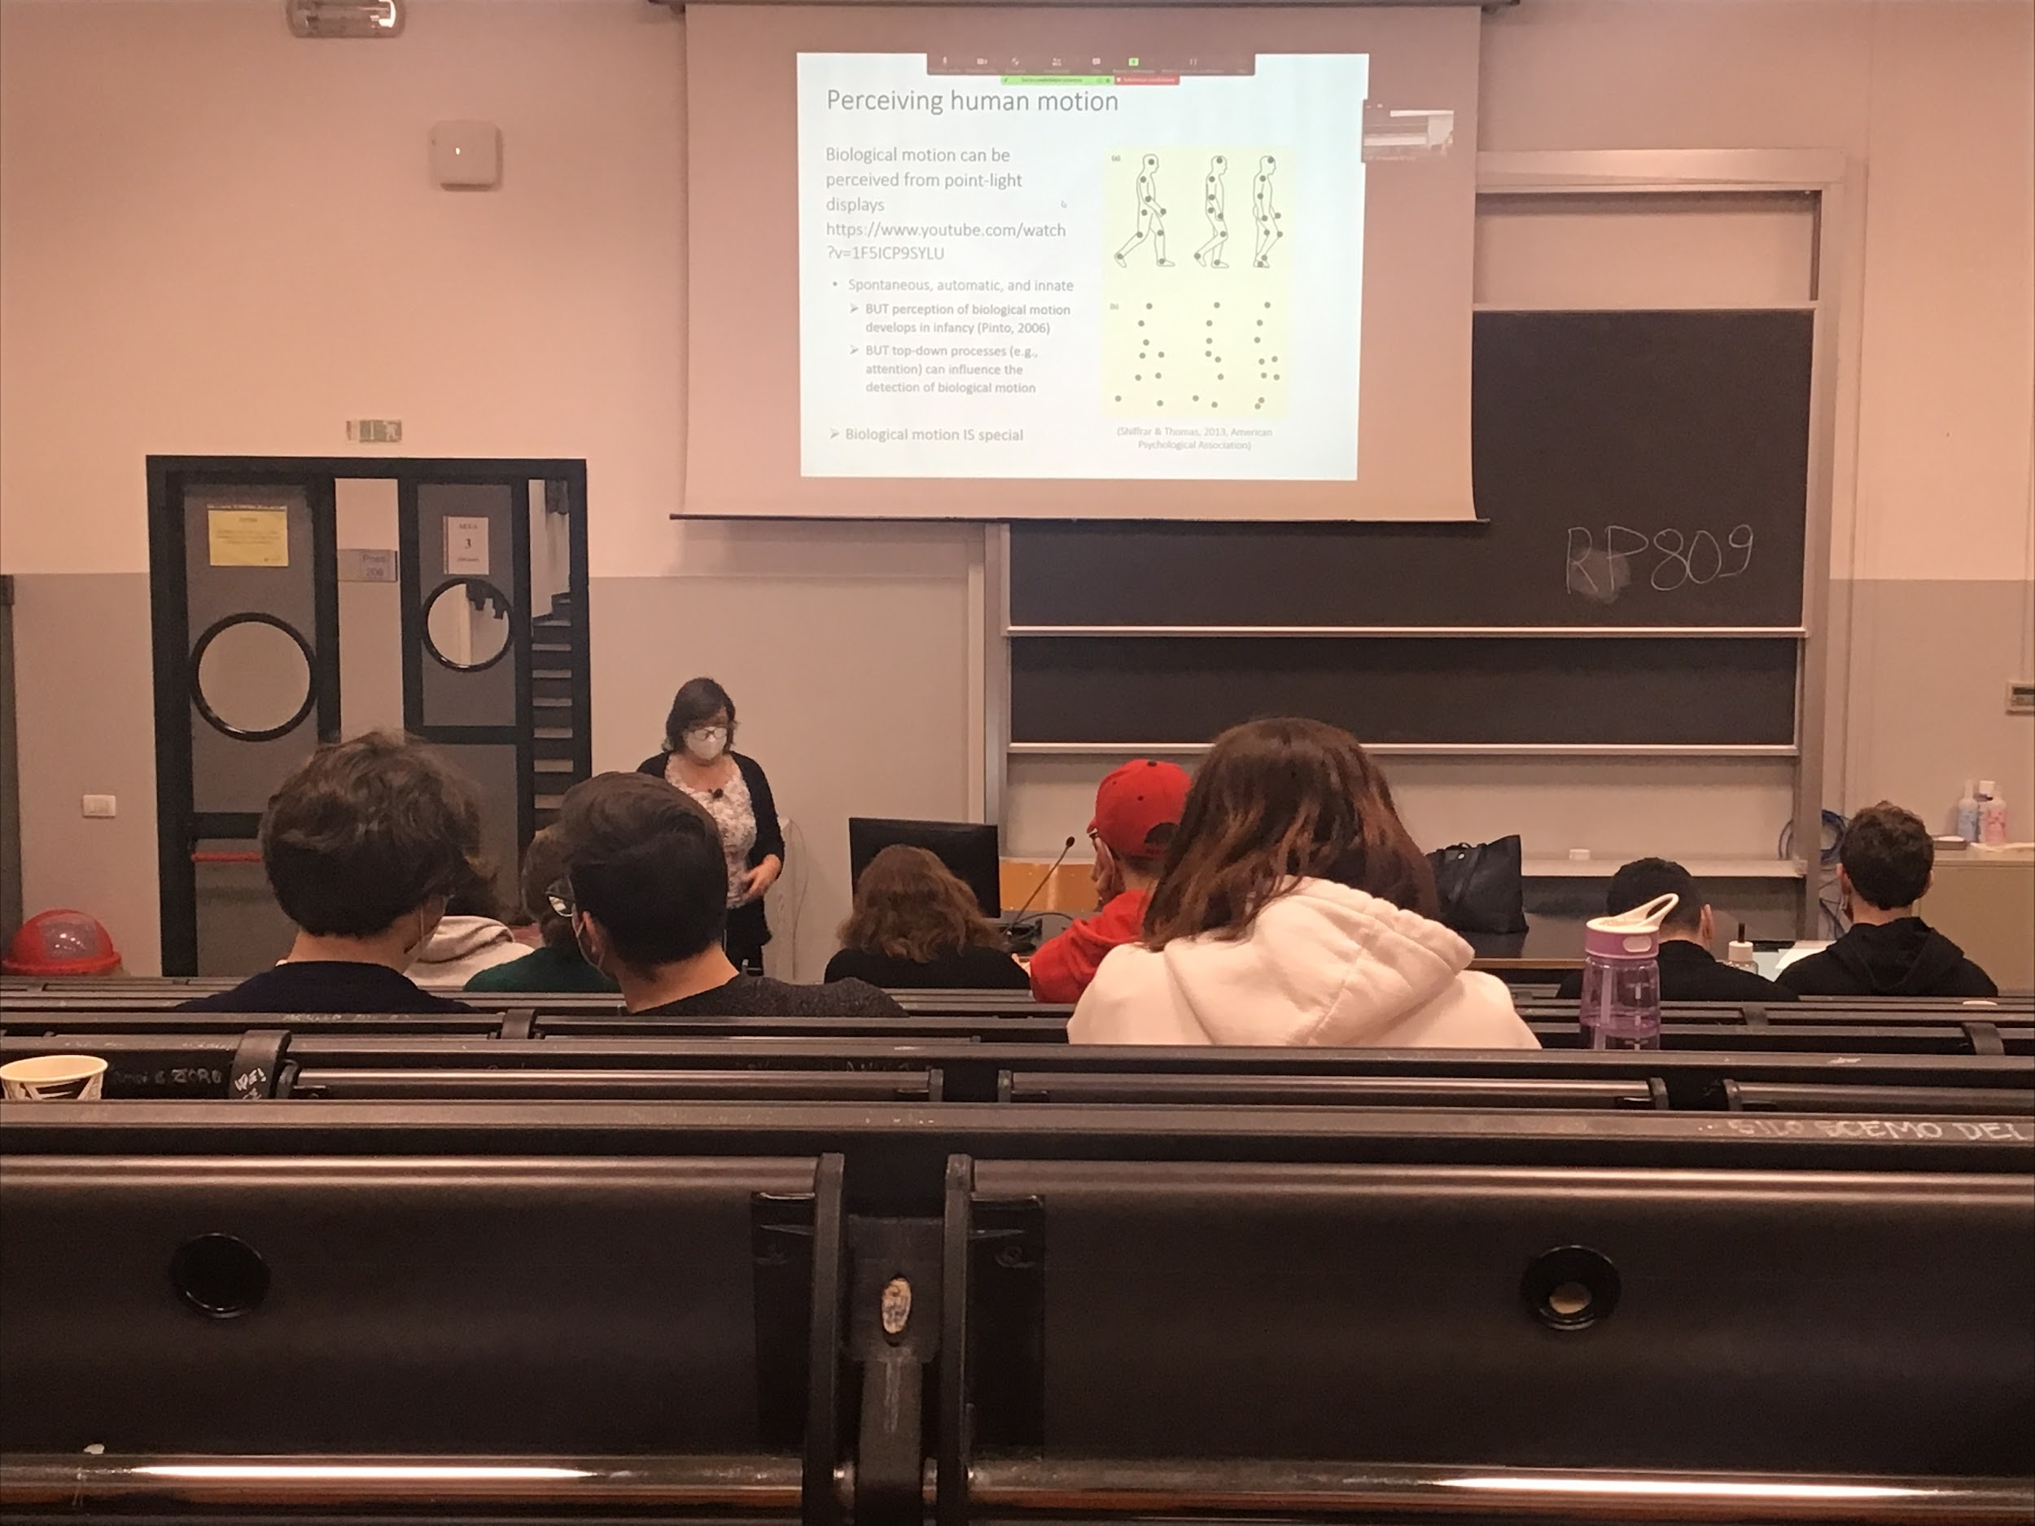

The only information transmitted to the brain is the information about motion, no other information can help the interpretation

Very efficient, does a pretty good job. The ability is bottom-up

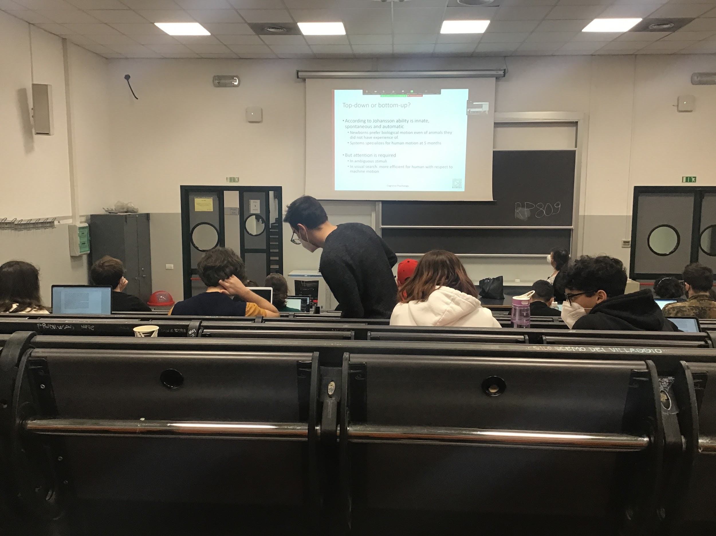

It is innate, newborn have the ability to compute biological motion, able to discriminate what they see

It improves over time, by the age of 5 old child are better of recognise biological human movement with respect to other biological movement

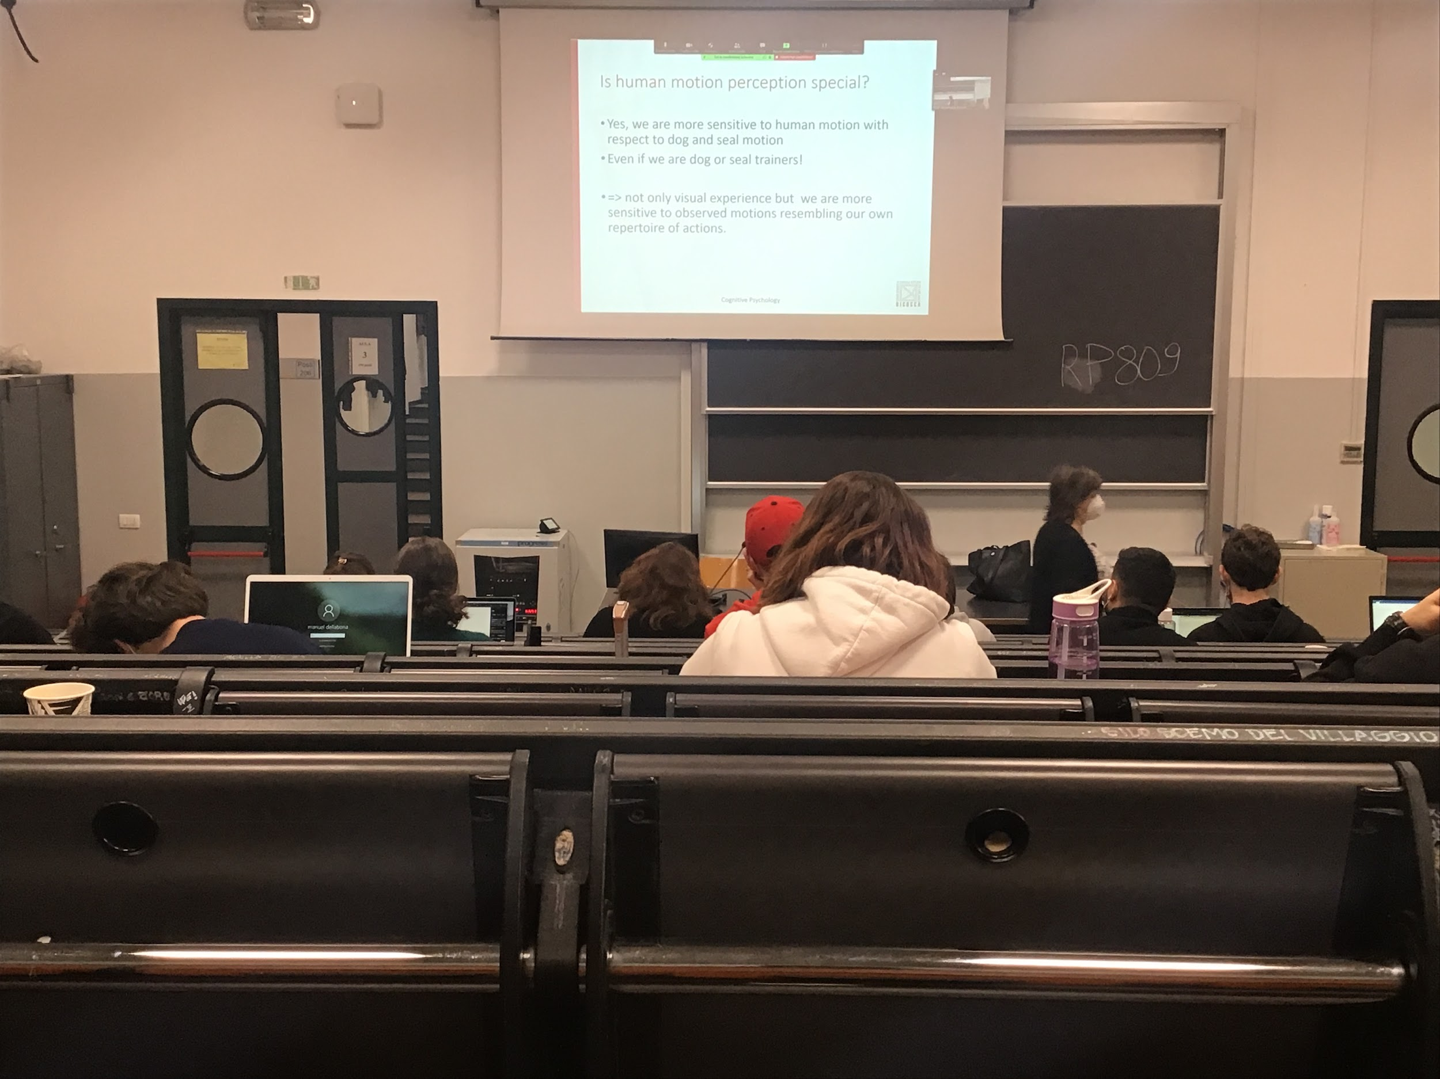

We are very good at detecnting human motion indipendeidly if you are a dog expert, still better at detect human motion

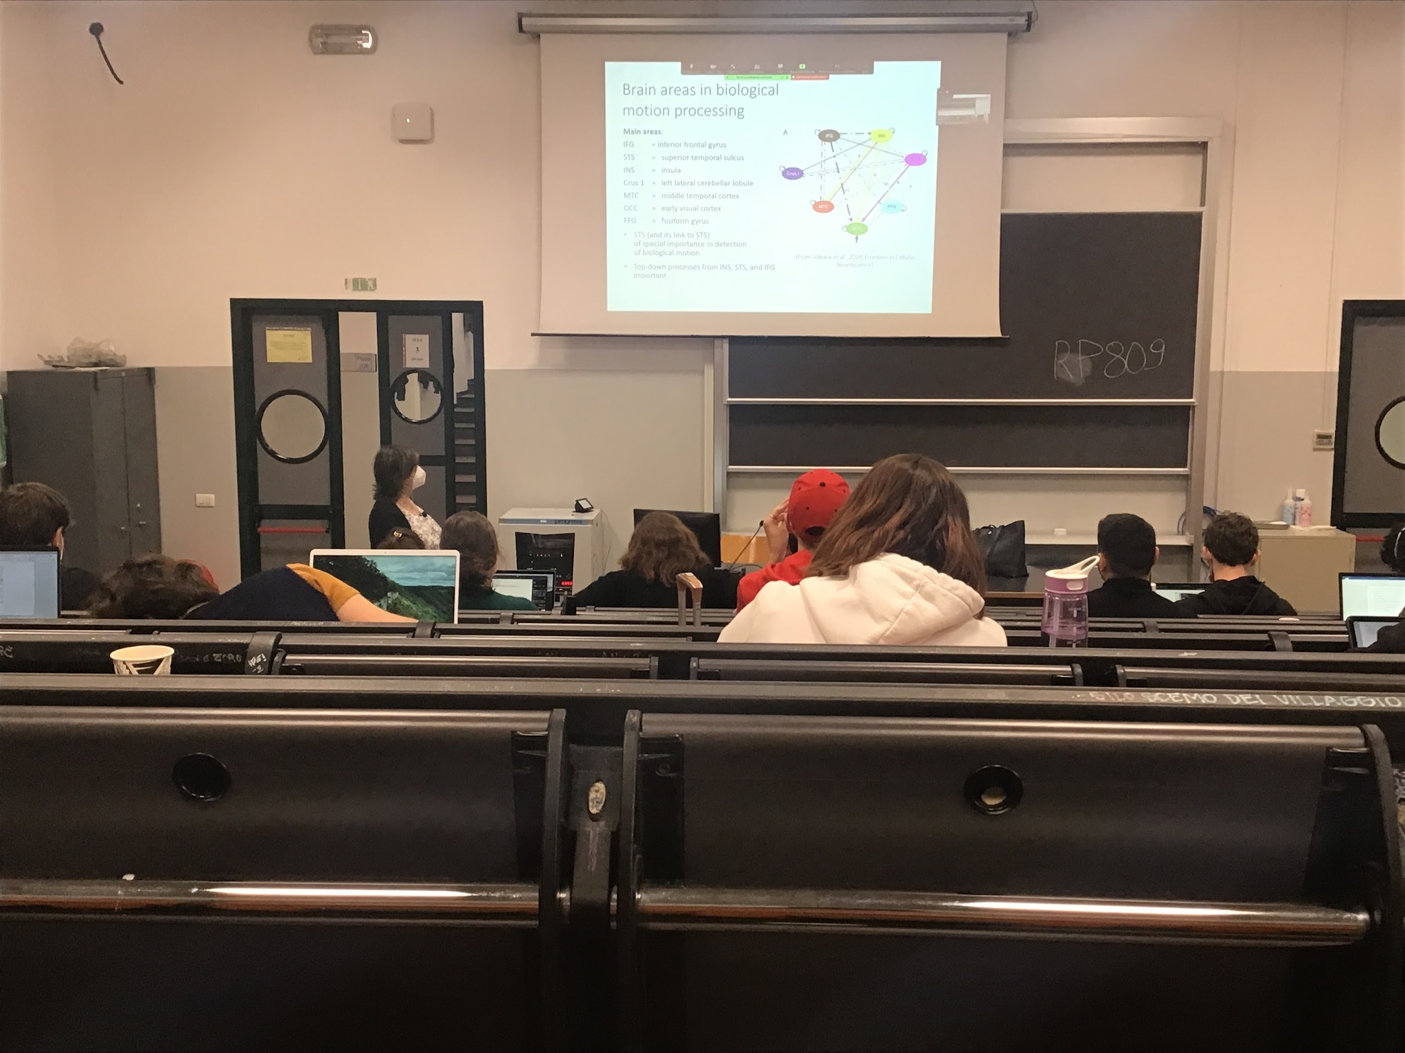

There are specific areas (more then one, a group of areas) that are activated during biological motion processing

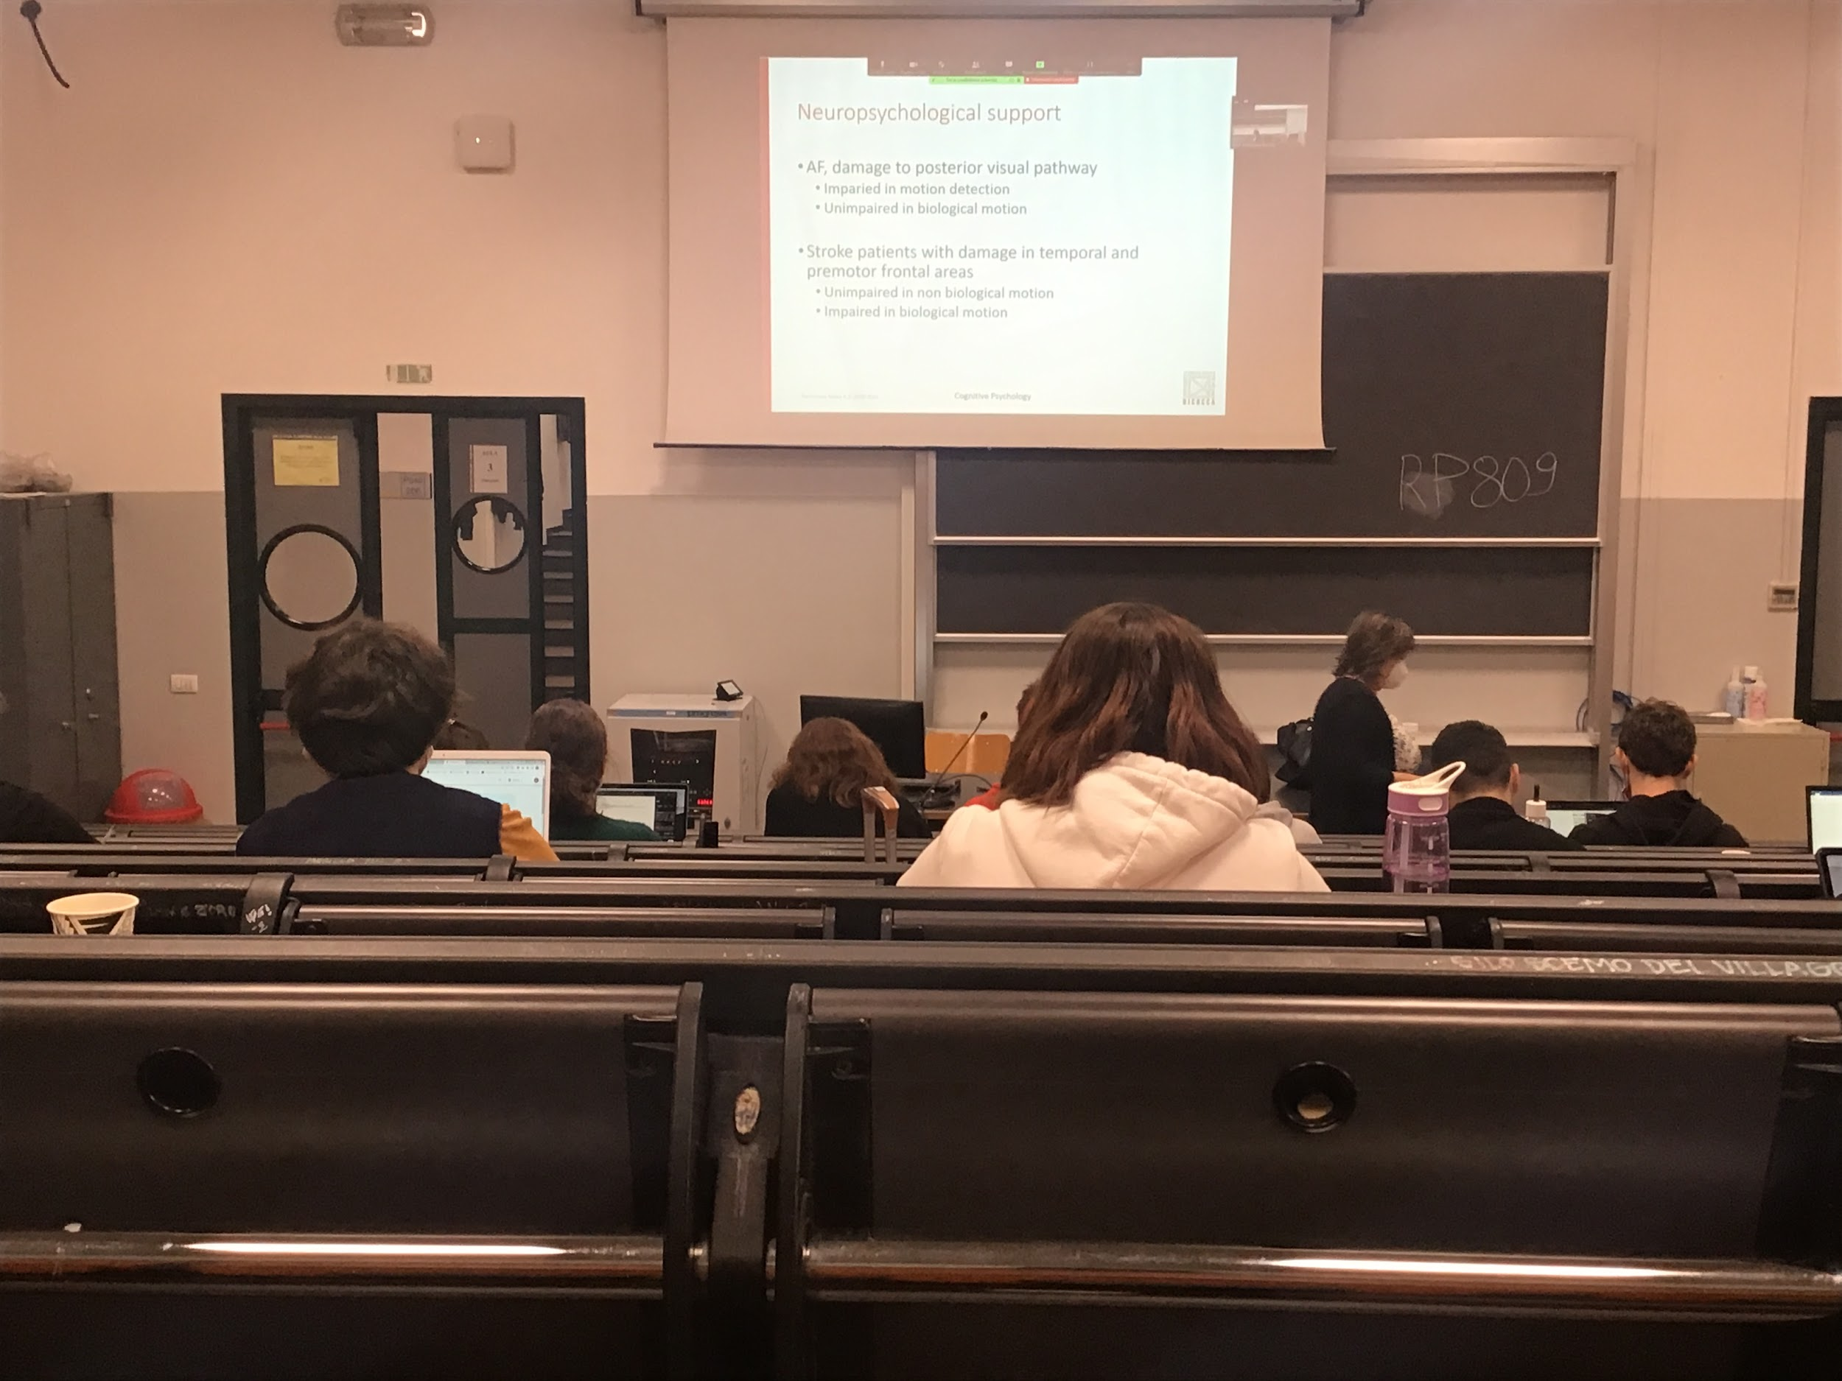

Neuropsychological support we find the **double dissociation**: we found patients that have one specific lesion and deficit in one aspect (deficit in biological motion, but not in standard motion detection) but also were found others patients with lesion in another area that have deficit in motion detection but no deficit in biological motion

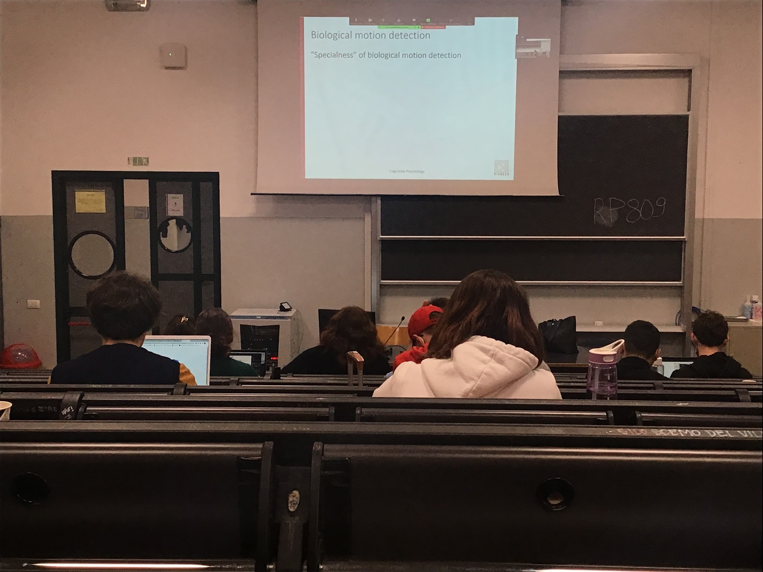

Why is biological motion special?

Biological motion, especially human biological motion is a very special motion, motion that I can reproduce (if I see a person walking I can copy the movement of that person)

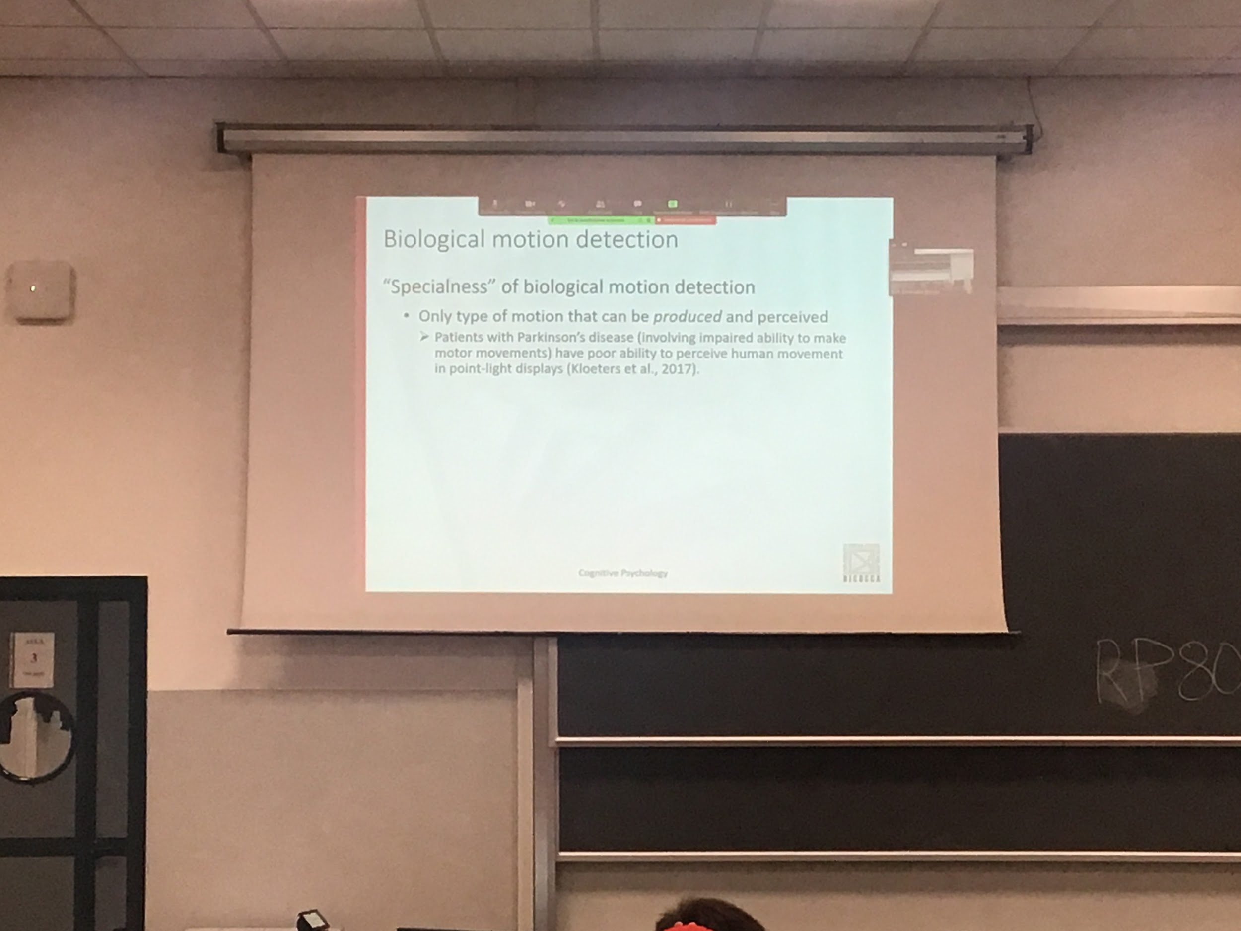

Some data in favour of the fact that if you are not able to produce movement → you are not good at perceiving movement

as if the ability of recognising biological motion is connected at least partially to the ability to reduce that motion

Patient with Parkinson have the inability to move (depending on the gravity of the disease) they have poor ability in detection motion

The fact that they can no produce a movement is correlated with the ability to not perceive

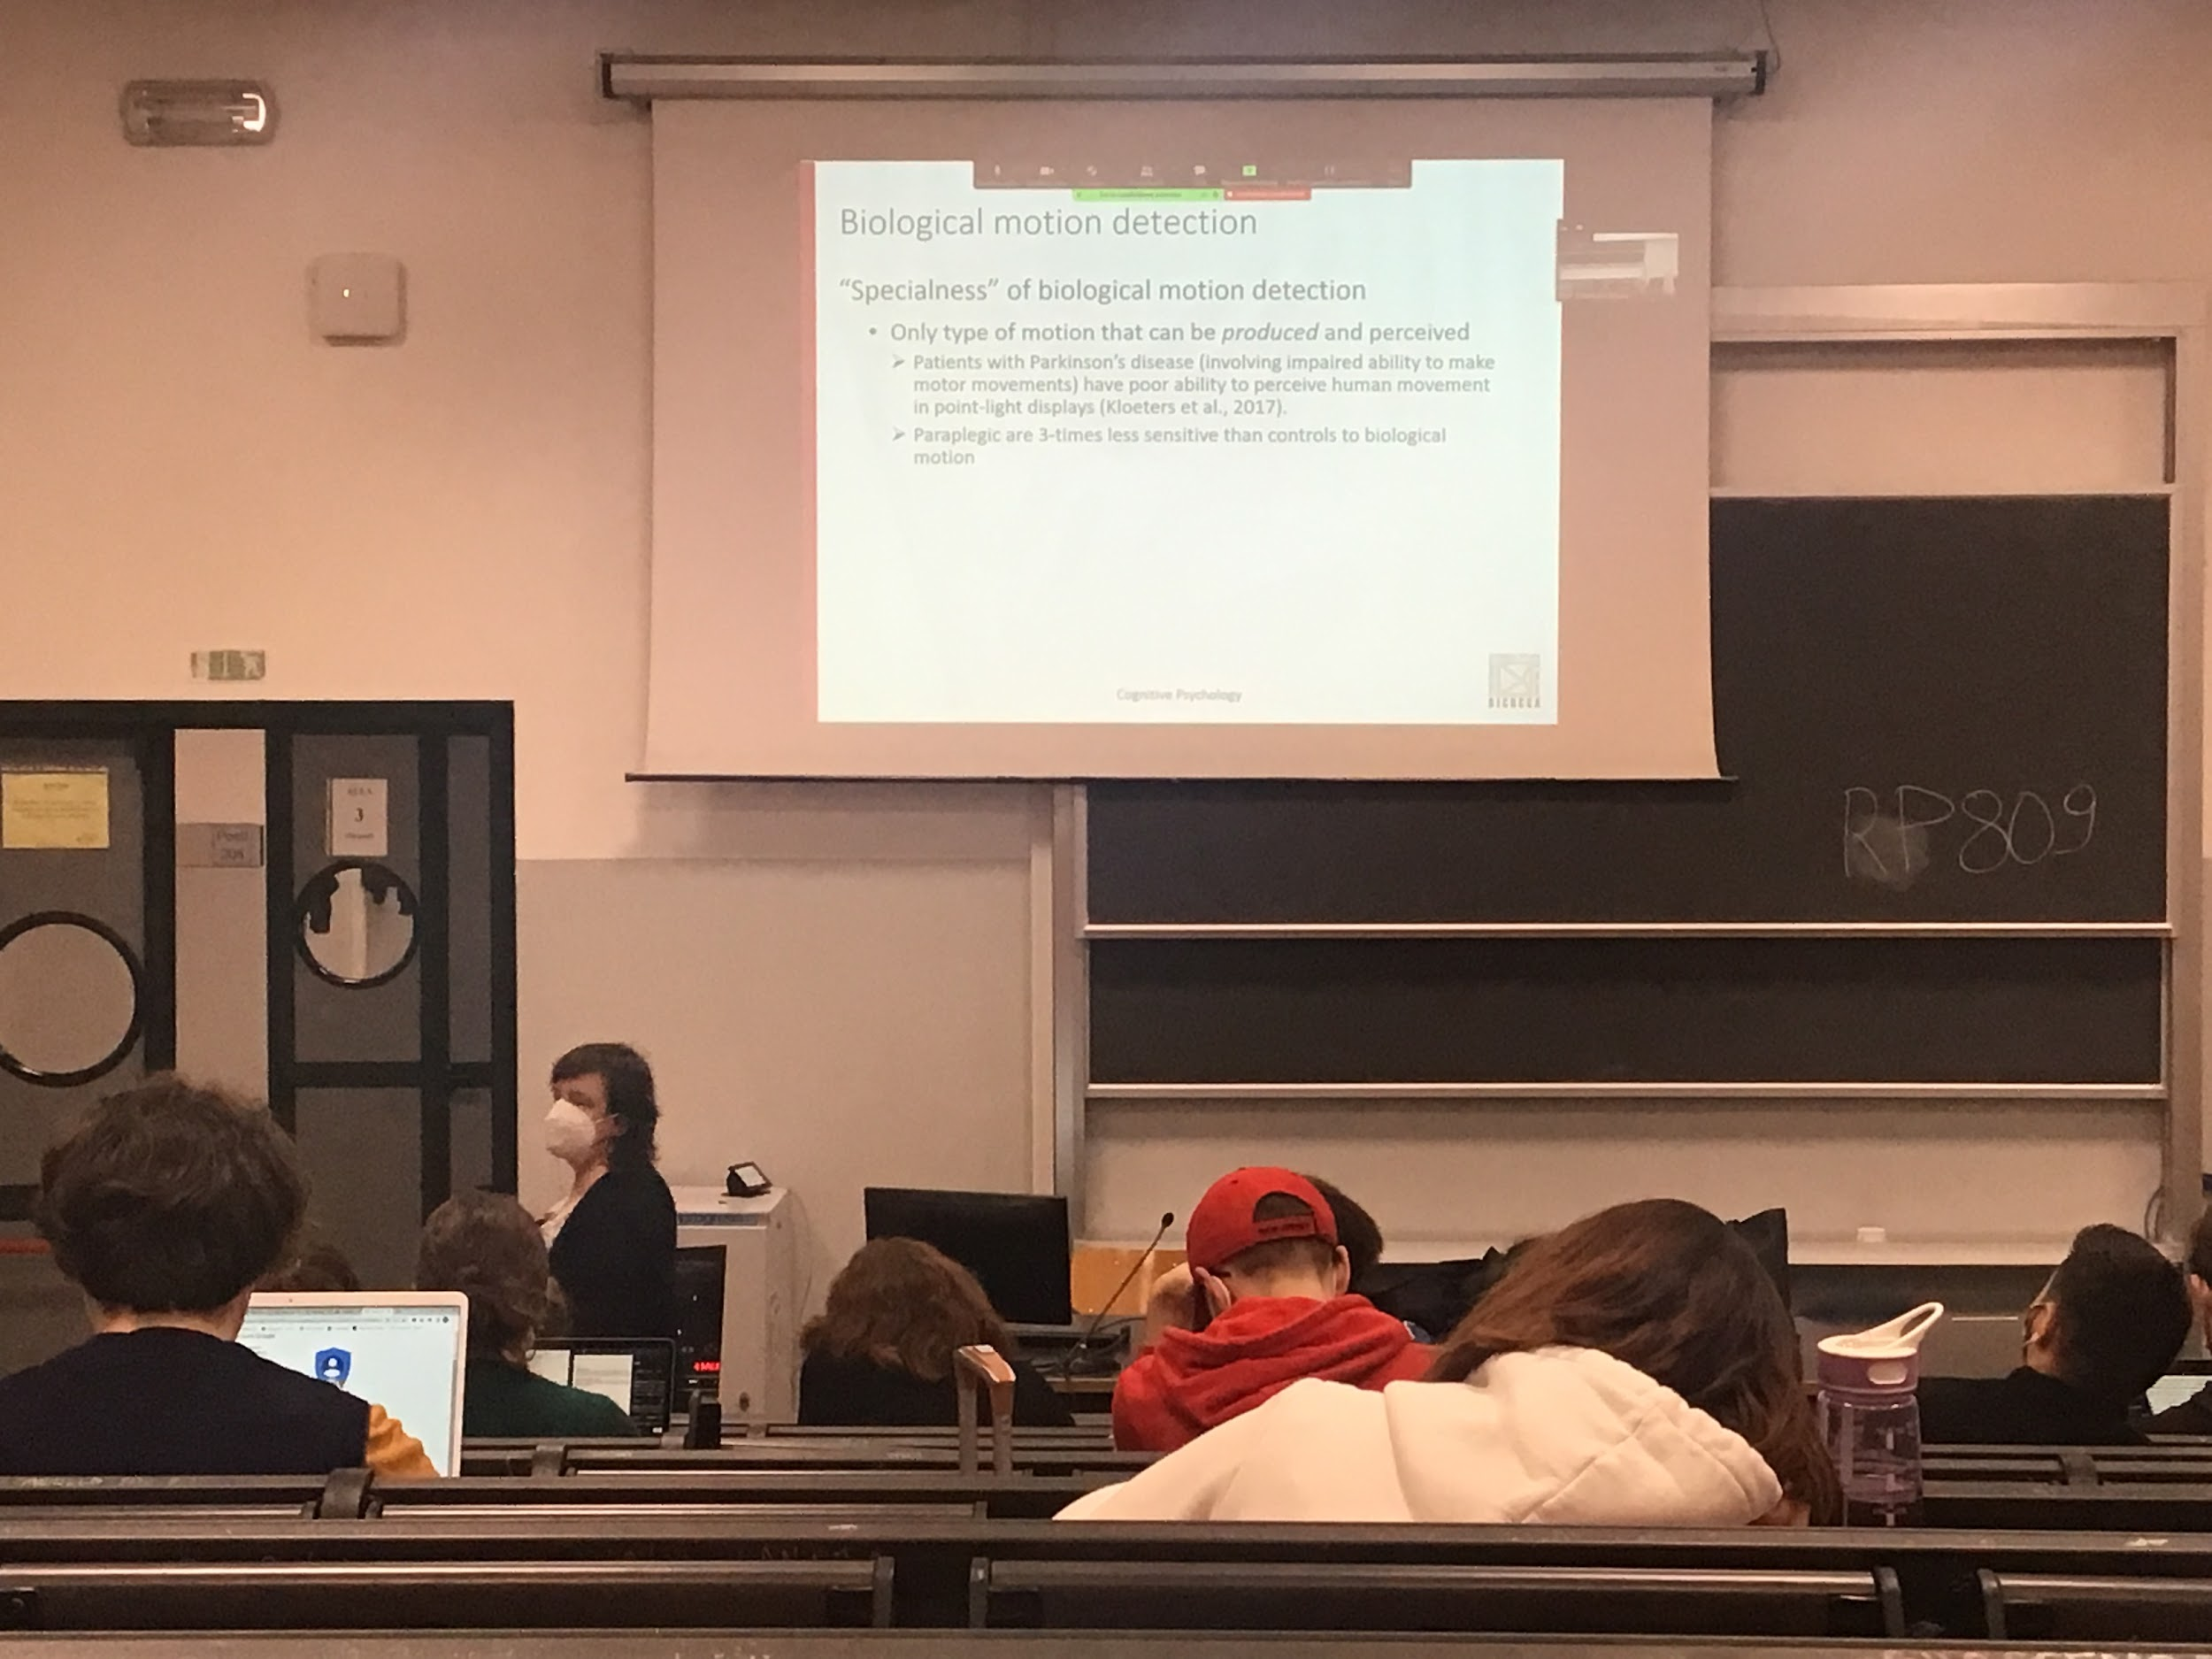

People that are paraplegic have a problem interaction in the spinal cord transmission of information, so they cannot move

Much more less sensitive to biological motion, inability to move connected to the lower than normal perception of human movement

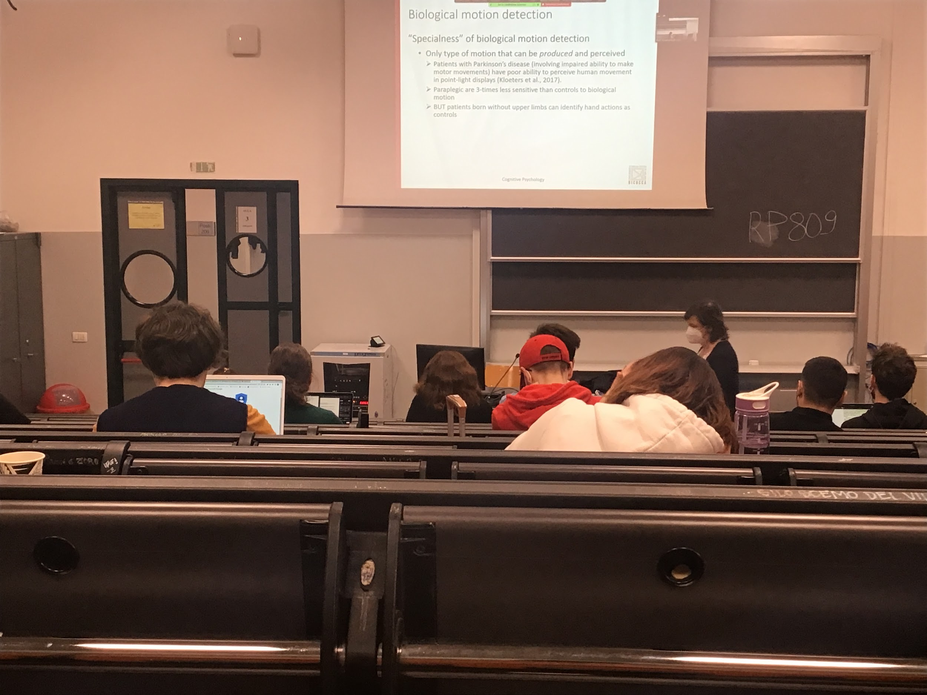

Correlational data: inability of Parkinson people that have inability to perceive human motion and inability to perceive and produce human motion

There are situation with people born without upper limbs (arti superiori) can perceive action of other people, even if they cannot produce it

Possibility that the **connection** between **perception** and **production** is just a way of the system to **improve performance** when we are in situations that are not clear, in which we have ambiguous informations

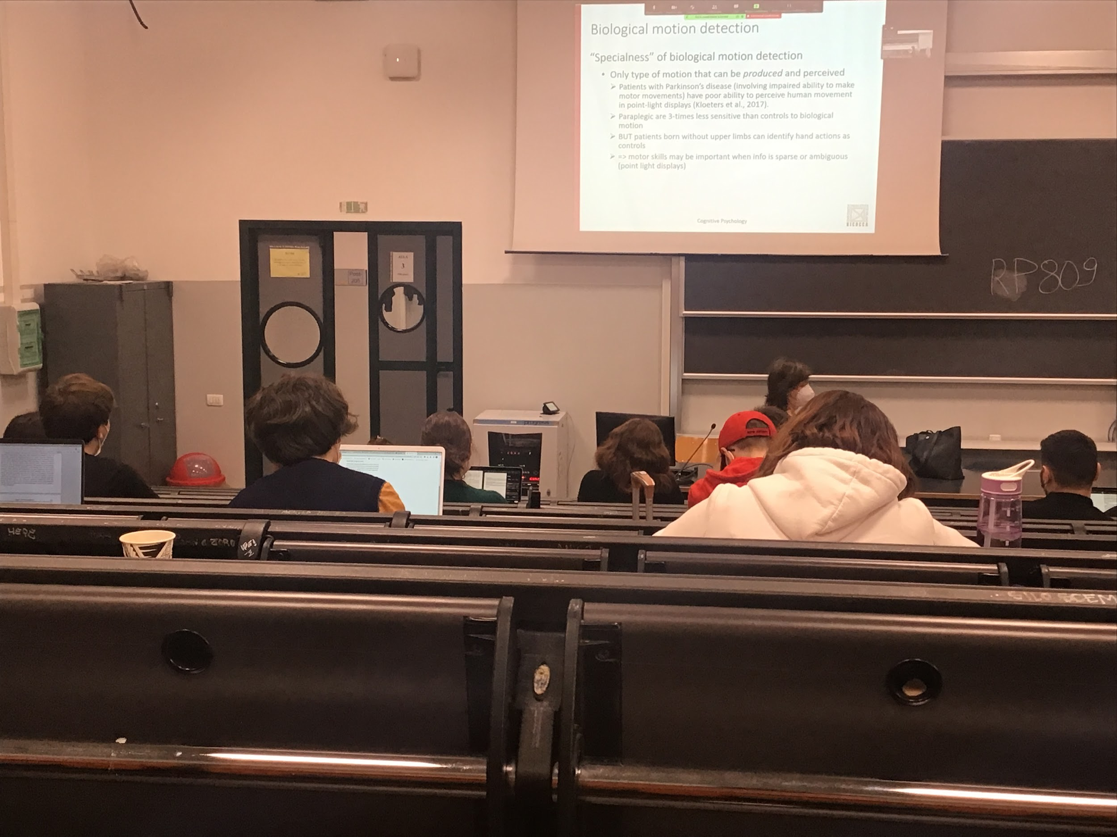

All this data are in favour on the fact that there is a correlation that we can not perceive and produce and vice versa

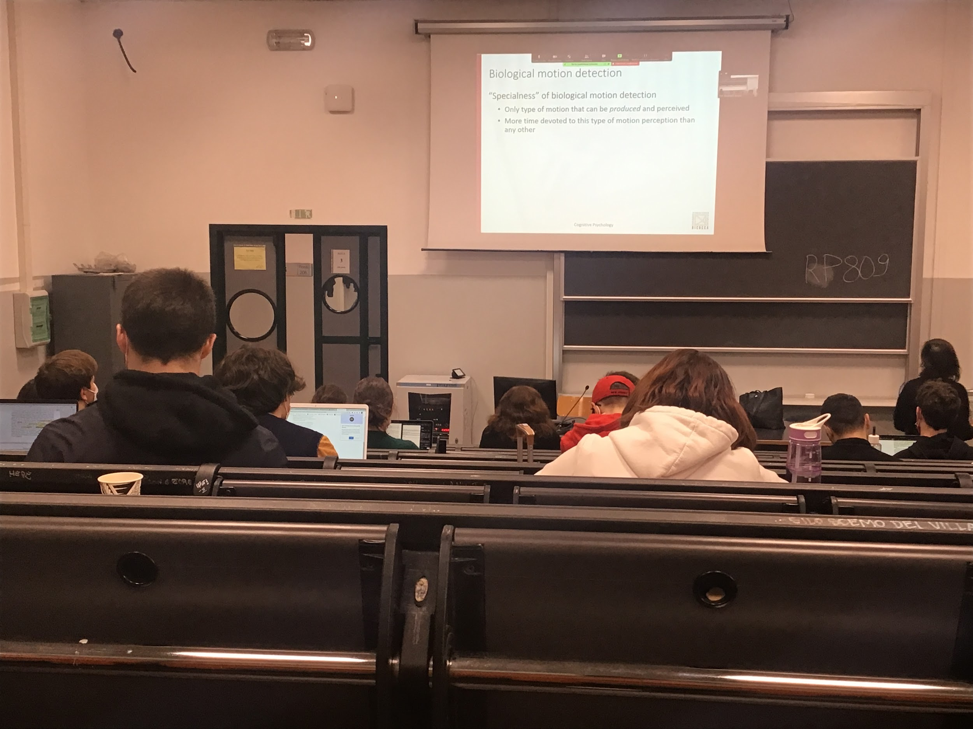

A possibility: biological motion is special because we dedicate a lot of time to this motion, for most of our life we are interacting with other people, learning over time to use this motion

True that experiences influences our perception of motion, better to detect motion of friends with respect someone that we don’t know

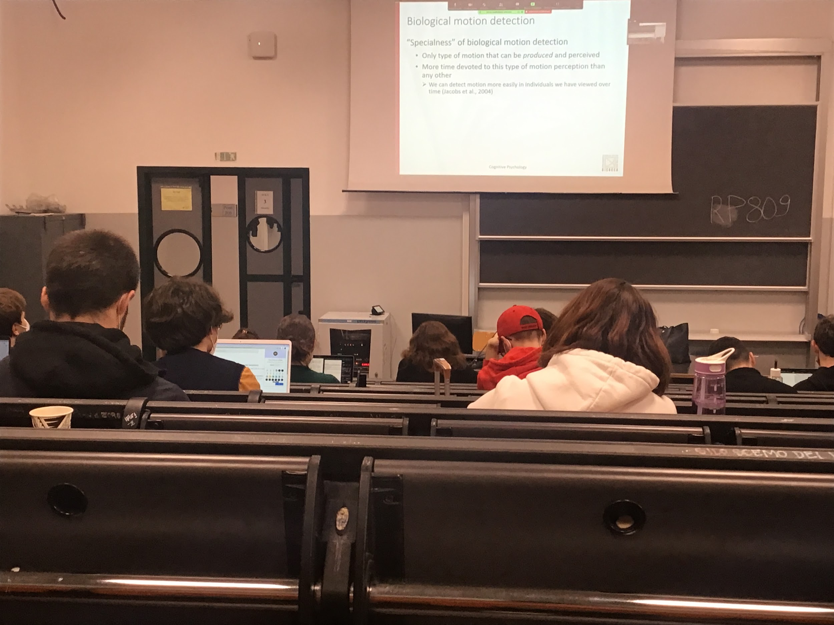

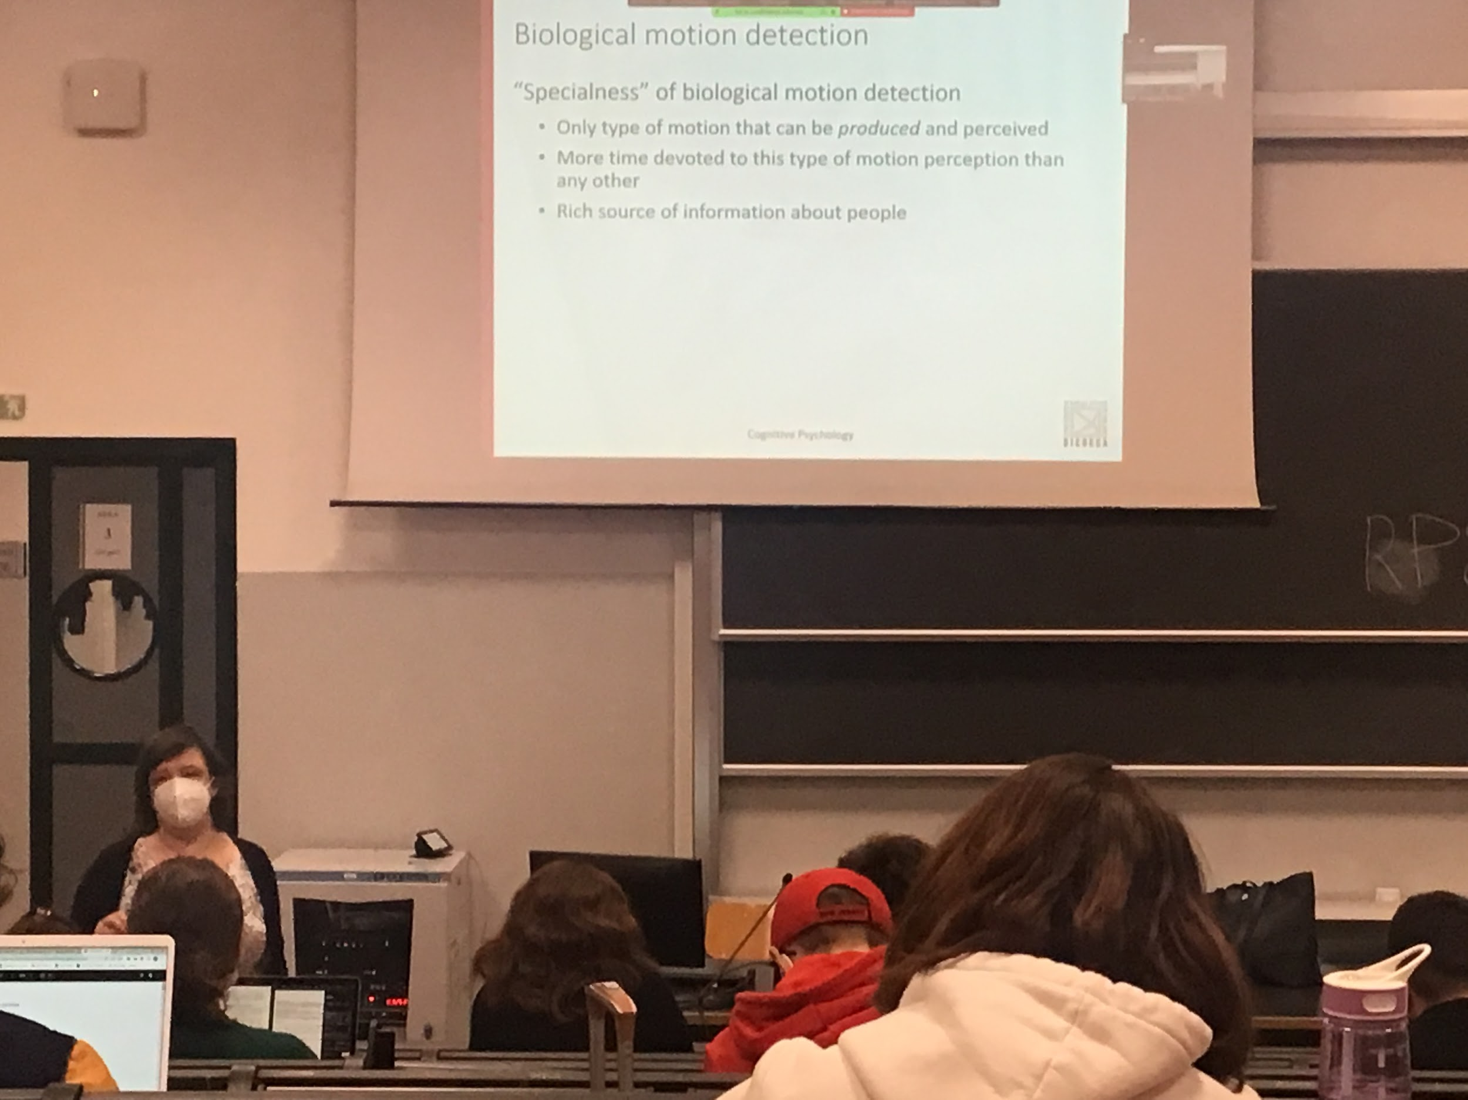

Tend to improve in this ability over time

Is important in social situation, when you see someone coming towards you you can understand if it is a friend or not, you can prepare yourself at their arrival

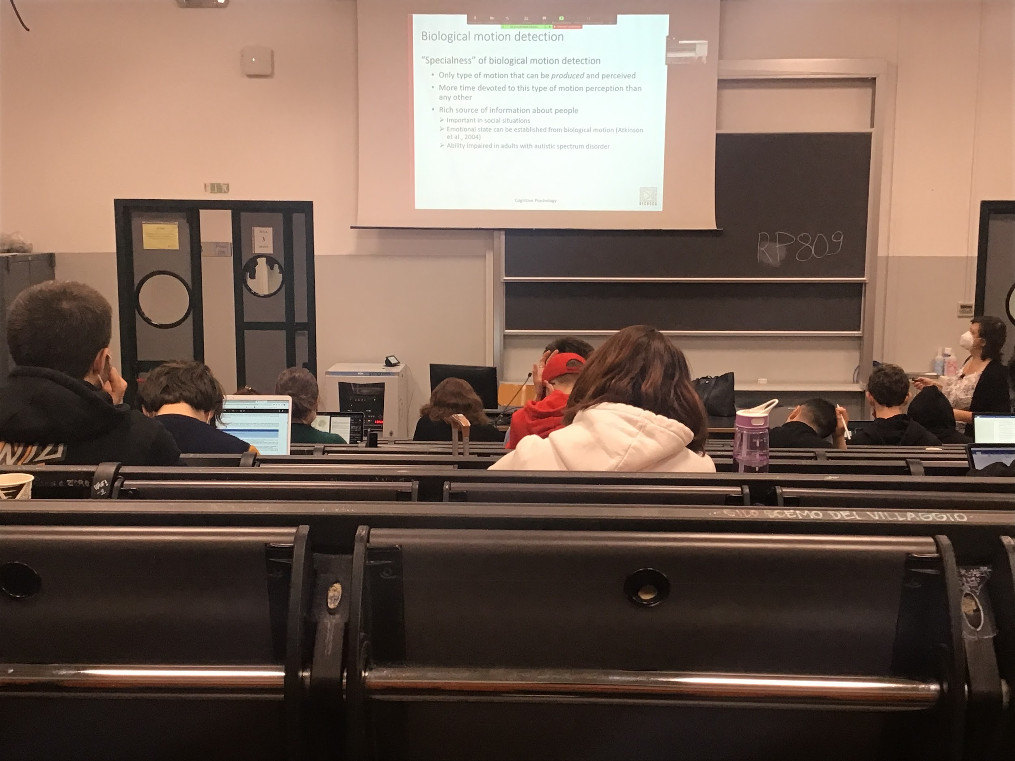

It is clear that we can detect the emotion state from the biological motion

This ability is impair with people who have some neurological deficits that are unable to perceive motion in general, they can detect motion but they are unable to associate this type of motion to any emotional information

Different parameters can be changed, by changing the movement of the dots we can detect if a person is sad or happy…

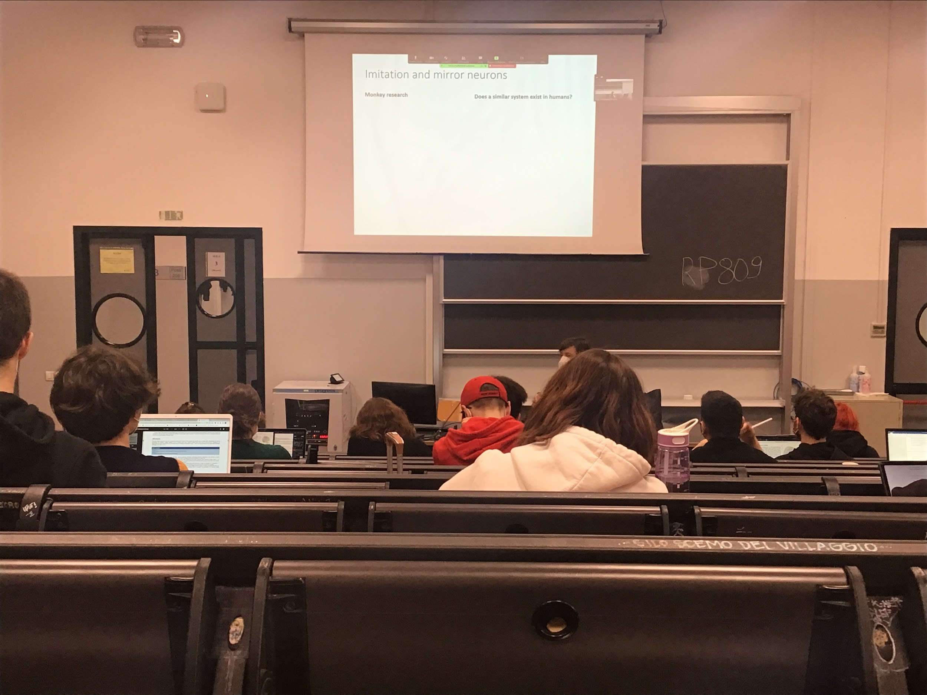

Monkey research found in the brain this type of neuro ***mirror neutrons***

Neutrons that fire (are activated) when the money perform a specific movement

* When the monkey perform a specific movement (grasping an object)
* When the monkey is doing a movement there is no activation
* When the monkey perceive movement there is activation
* When the monkey do a different movement there is no activation

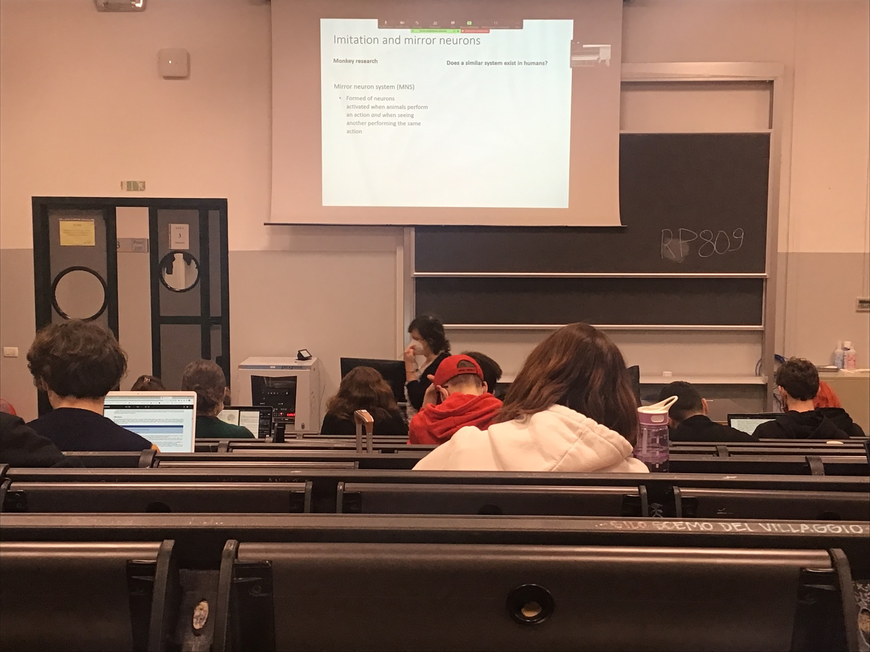

Neuronal that respons when the monkey perform a specific movement

Neurons that are selective for a specific type of movement

Also active when the monkey is shown another monkey doing the same movement

**Mirror**: active when they perform an action (grasping an apple) AND when they see another person/monkey perform the same action

Called mirror because they respond to an action made by you but also an action made by me

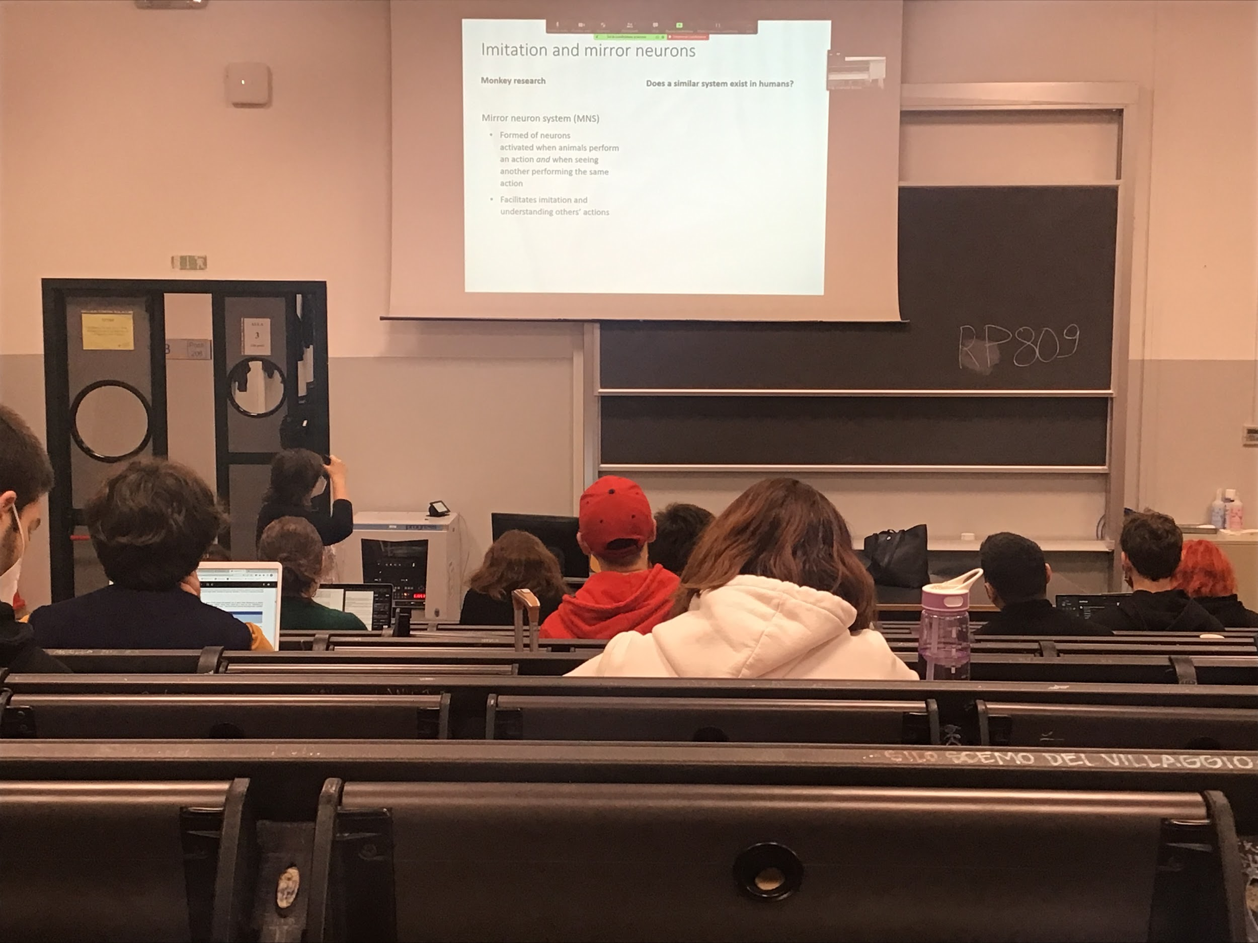

Mirror neurons facilitates imitations and understanding others people actions

Mirror neurons are found in area V5 and in the superior temporal source

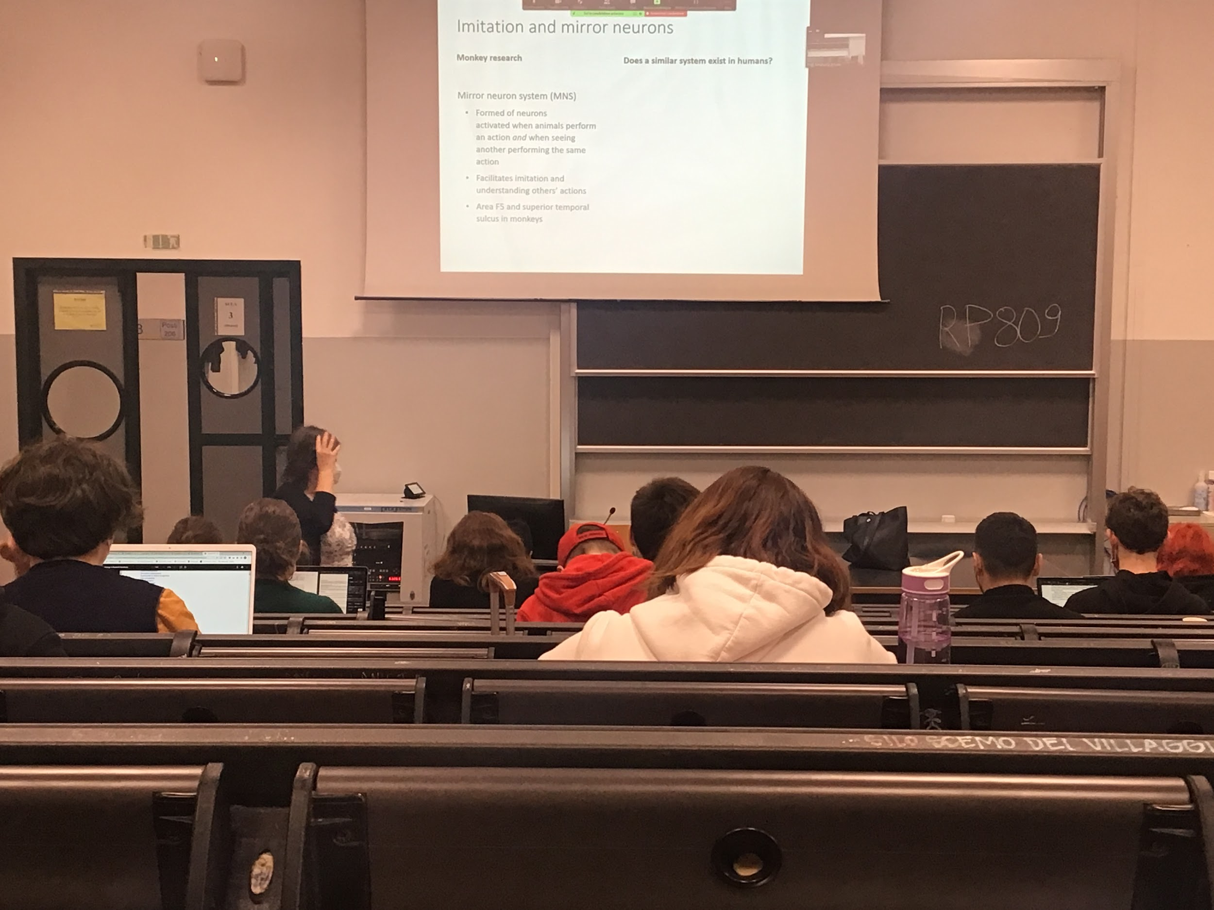

Equivalent thing in the human brain of the Mirror neurons of the monkey?

Not deep as the level of single neurons in the money, we looked at general activation with FMRI and other techniques.

Correlation evidence

Their discovery was very important for this type of information

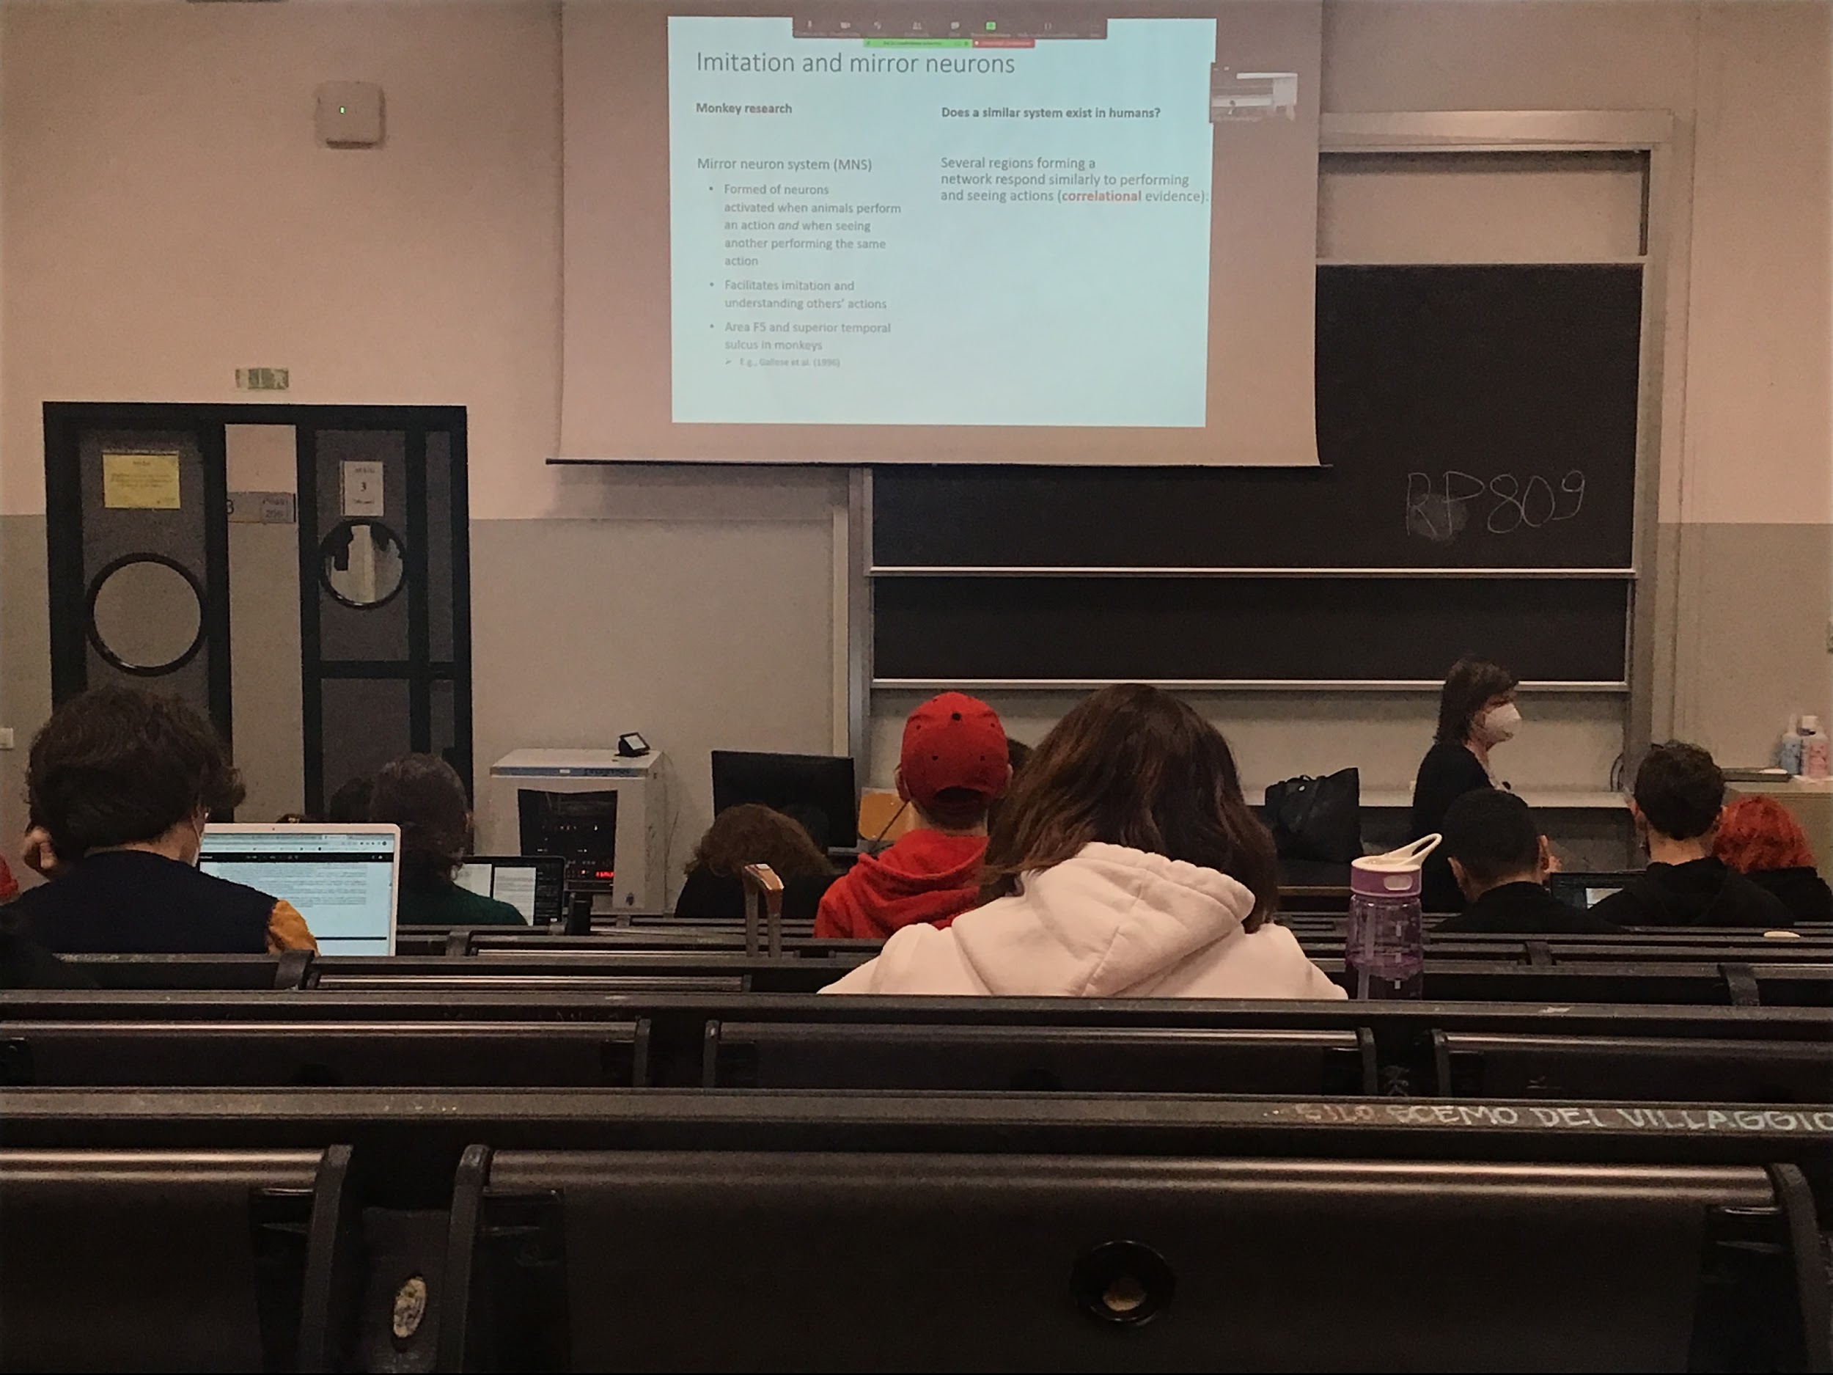

Found that there are several regions that are connected and perform a network that respond more or less the same way when the people perform an action that is the same performed by others

Correlation evidence: we see that the two things go together, same activation in the same brain areas for the perceive and acted movement (you can not go as deep as with monkeys, can be sure that actually are the *same* neurons but they are in the same area)

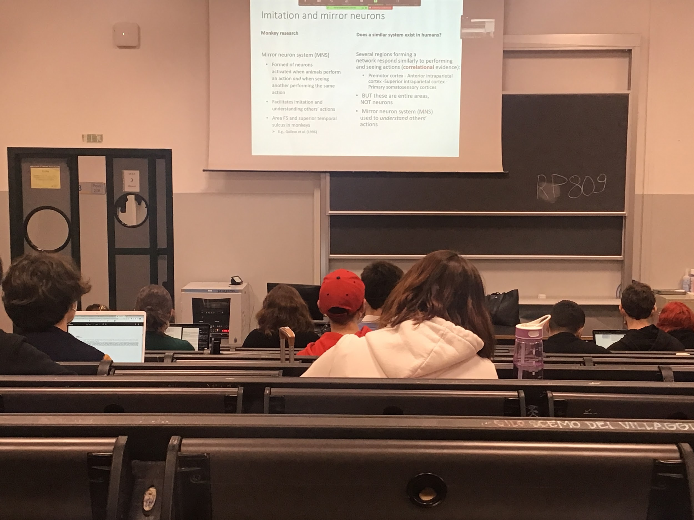

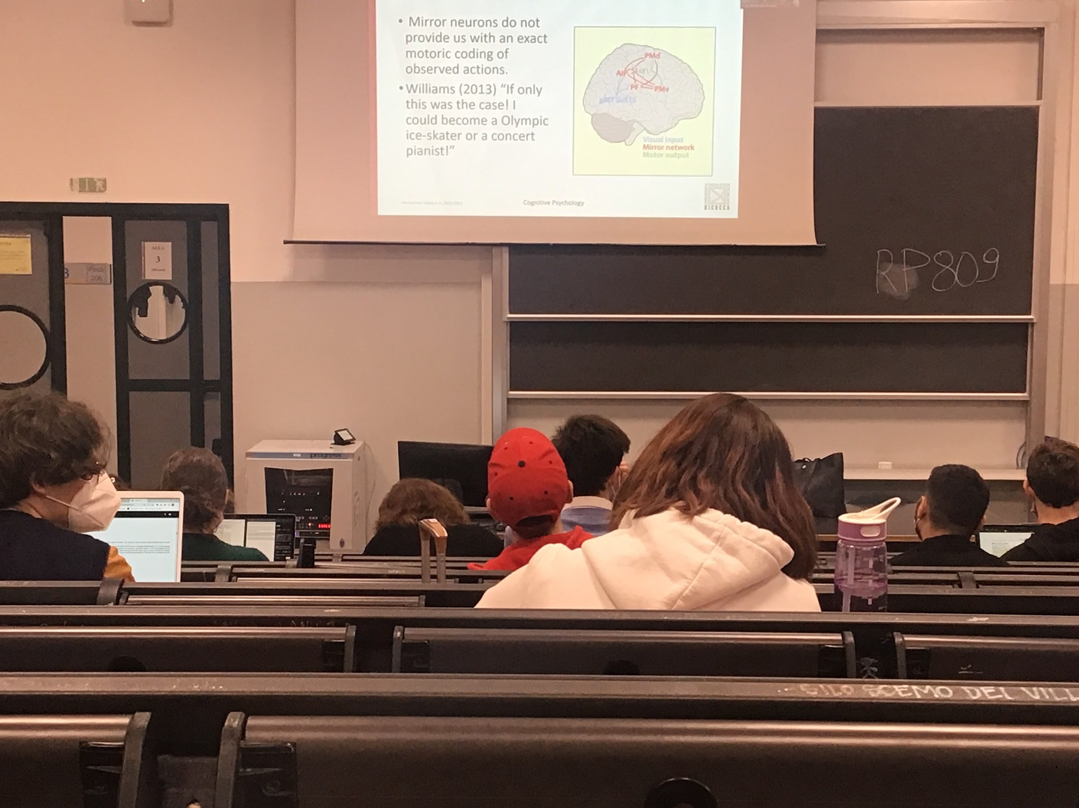

Many interconnections. These are entries areas, not single neurons

When I have neurons (aka mirror neurons) that respond do another person perceiving an action, does not mean that is coding exactly what I should do to perform the same action (otherwise if I see Berrettini playing tennis I would be as good as him)

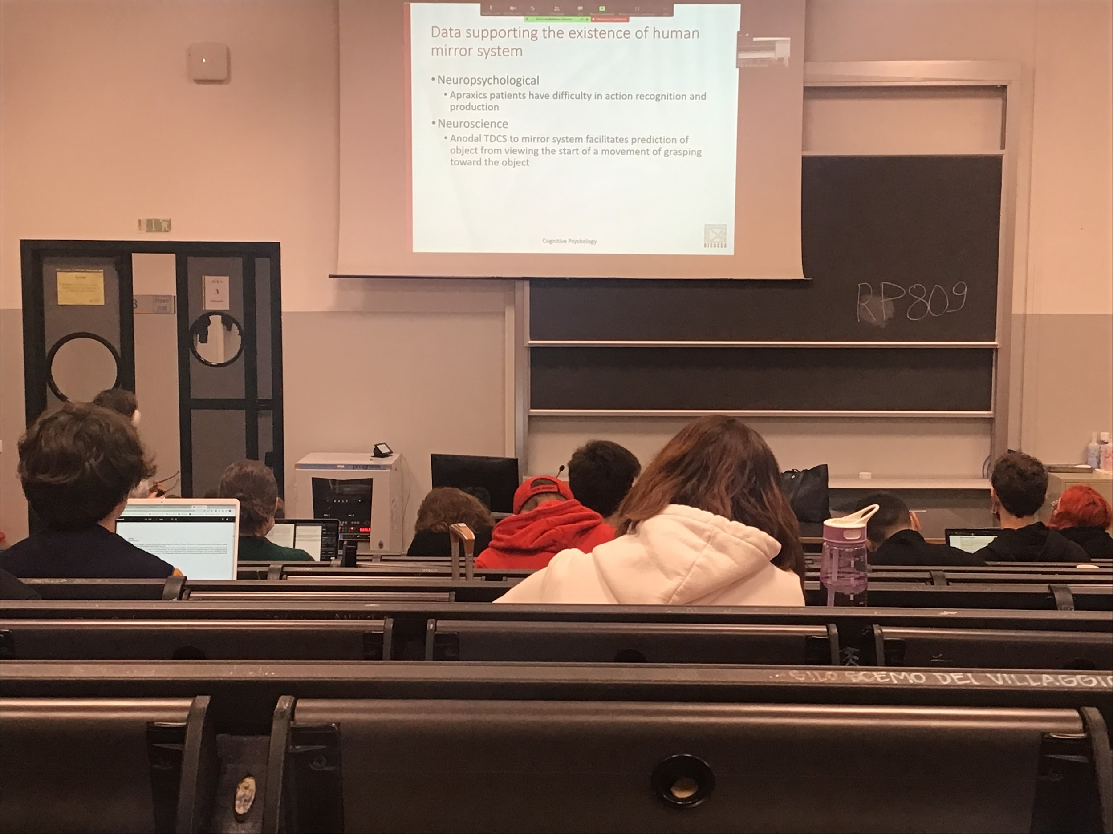

Data to support human mirror system

**Apraxia**: people with specific brain lesion difficulty in movement, can not perform fluid movement

Experiment: How good we are to understand an action just by looking at a few seconds. Record the action of somebody grasping the object and stop after the first part. If you have a perfect mirror system you should be able to distinguish the action even from the beginning

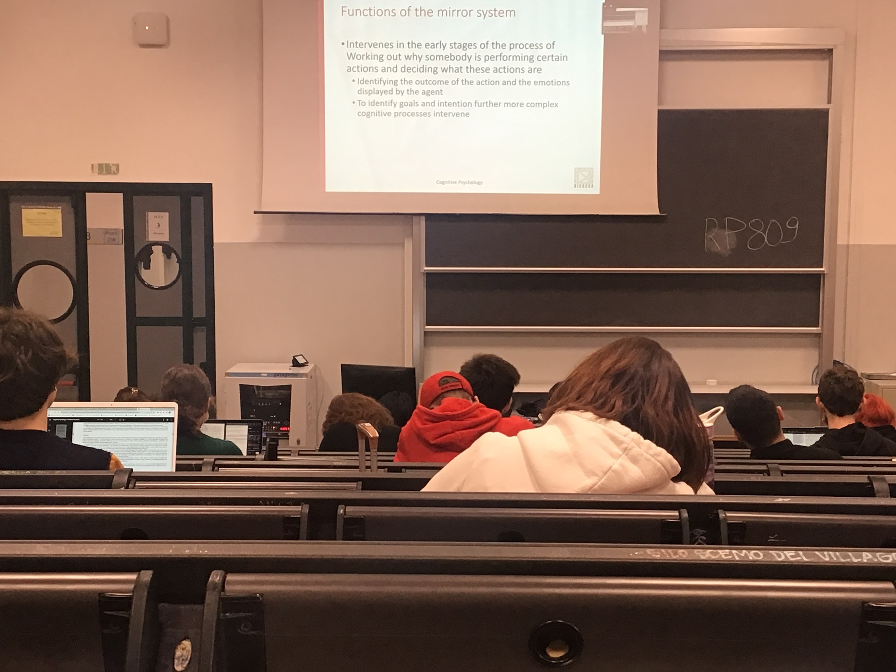

Mirror system is not for creating and reproducing exactly others people movement, but it is needed what is the other person doing

It is needed to identify what is the goal and the intention of others

Try to interpret the other person

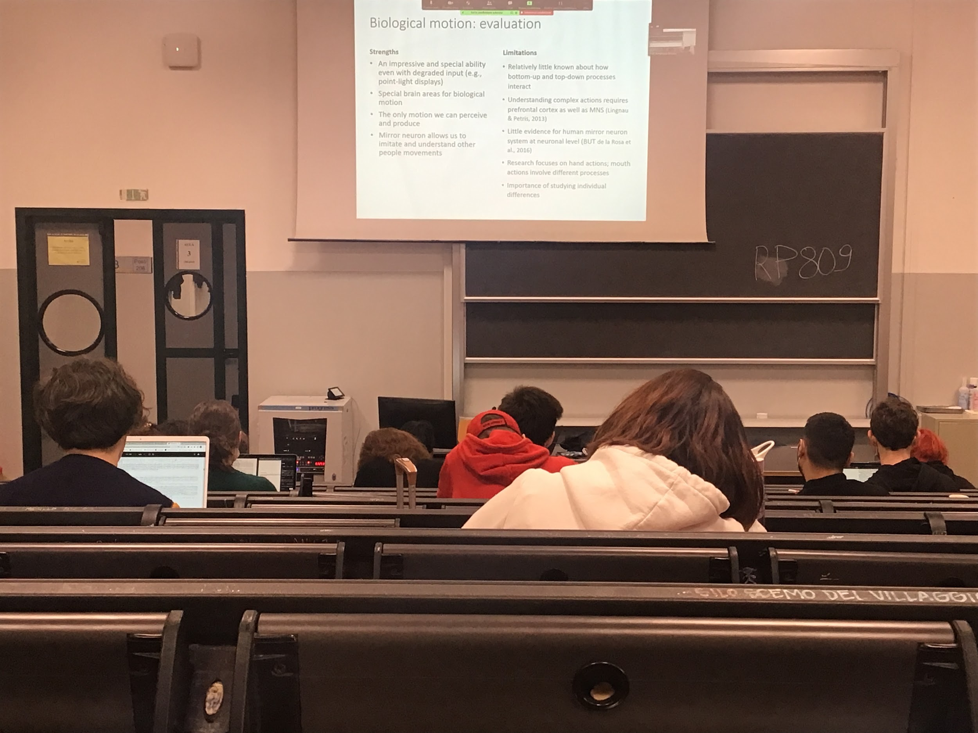

Is fundamental the ability for us to detect biological motion, very special ability

Important ability to detect biological motion, very good even if the only information is the one of movement

Mirror neurons help us understand other people intention

Mirror neurons also used to prediction

**Motion perception and action**

## Change blindness

**Attention is needed in the human system for one reason**. If we study everything at the same time there would be to many informations, resources are limited complex, can not study everything in detail, limit number of computational power

The system has develops the ability to select informations to focus on to achieve our goals

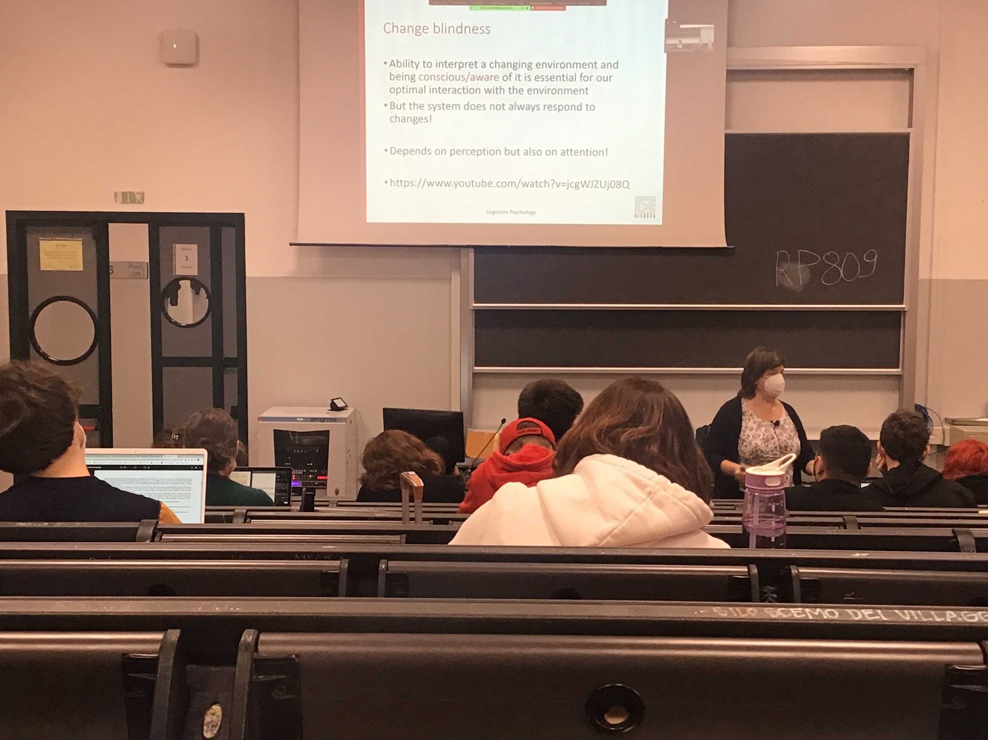

The feeling is that you know exactly what is happening in front of me, but it is not true

The system is unable to code everything everytime

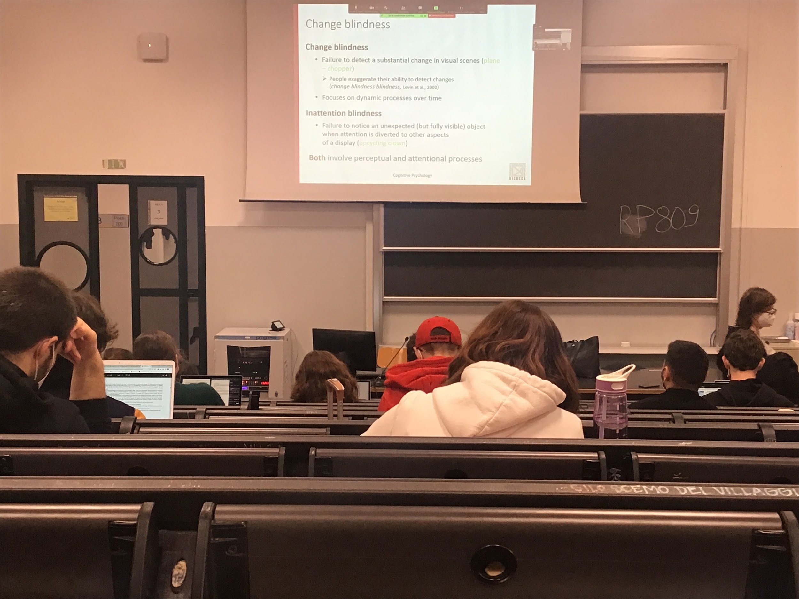

* **Change blindness**: inability to detect a change in the visual scene, even if the change is big you don’t recognise it fast
* **Inattentional blindness**: if focus on something unable to see very strange situation

Changing image experiment

Attention is selective

Not everything that is recorded from your eyes is actually perceive

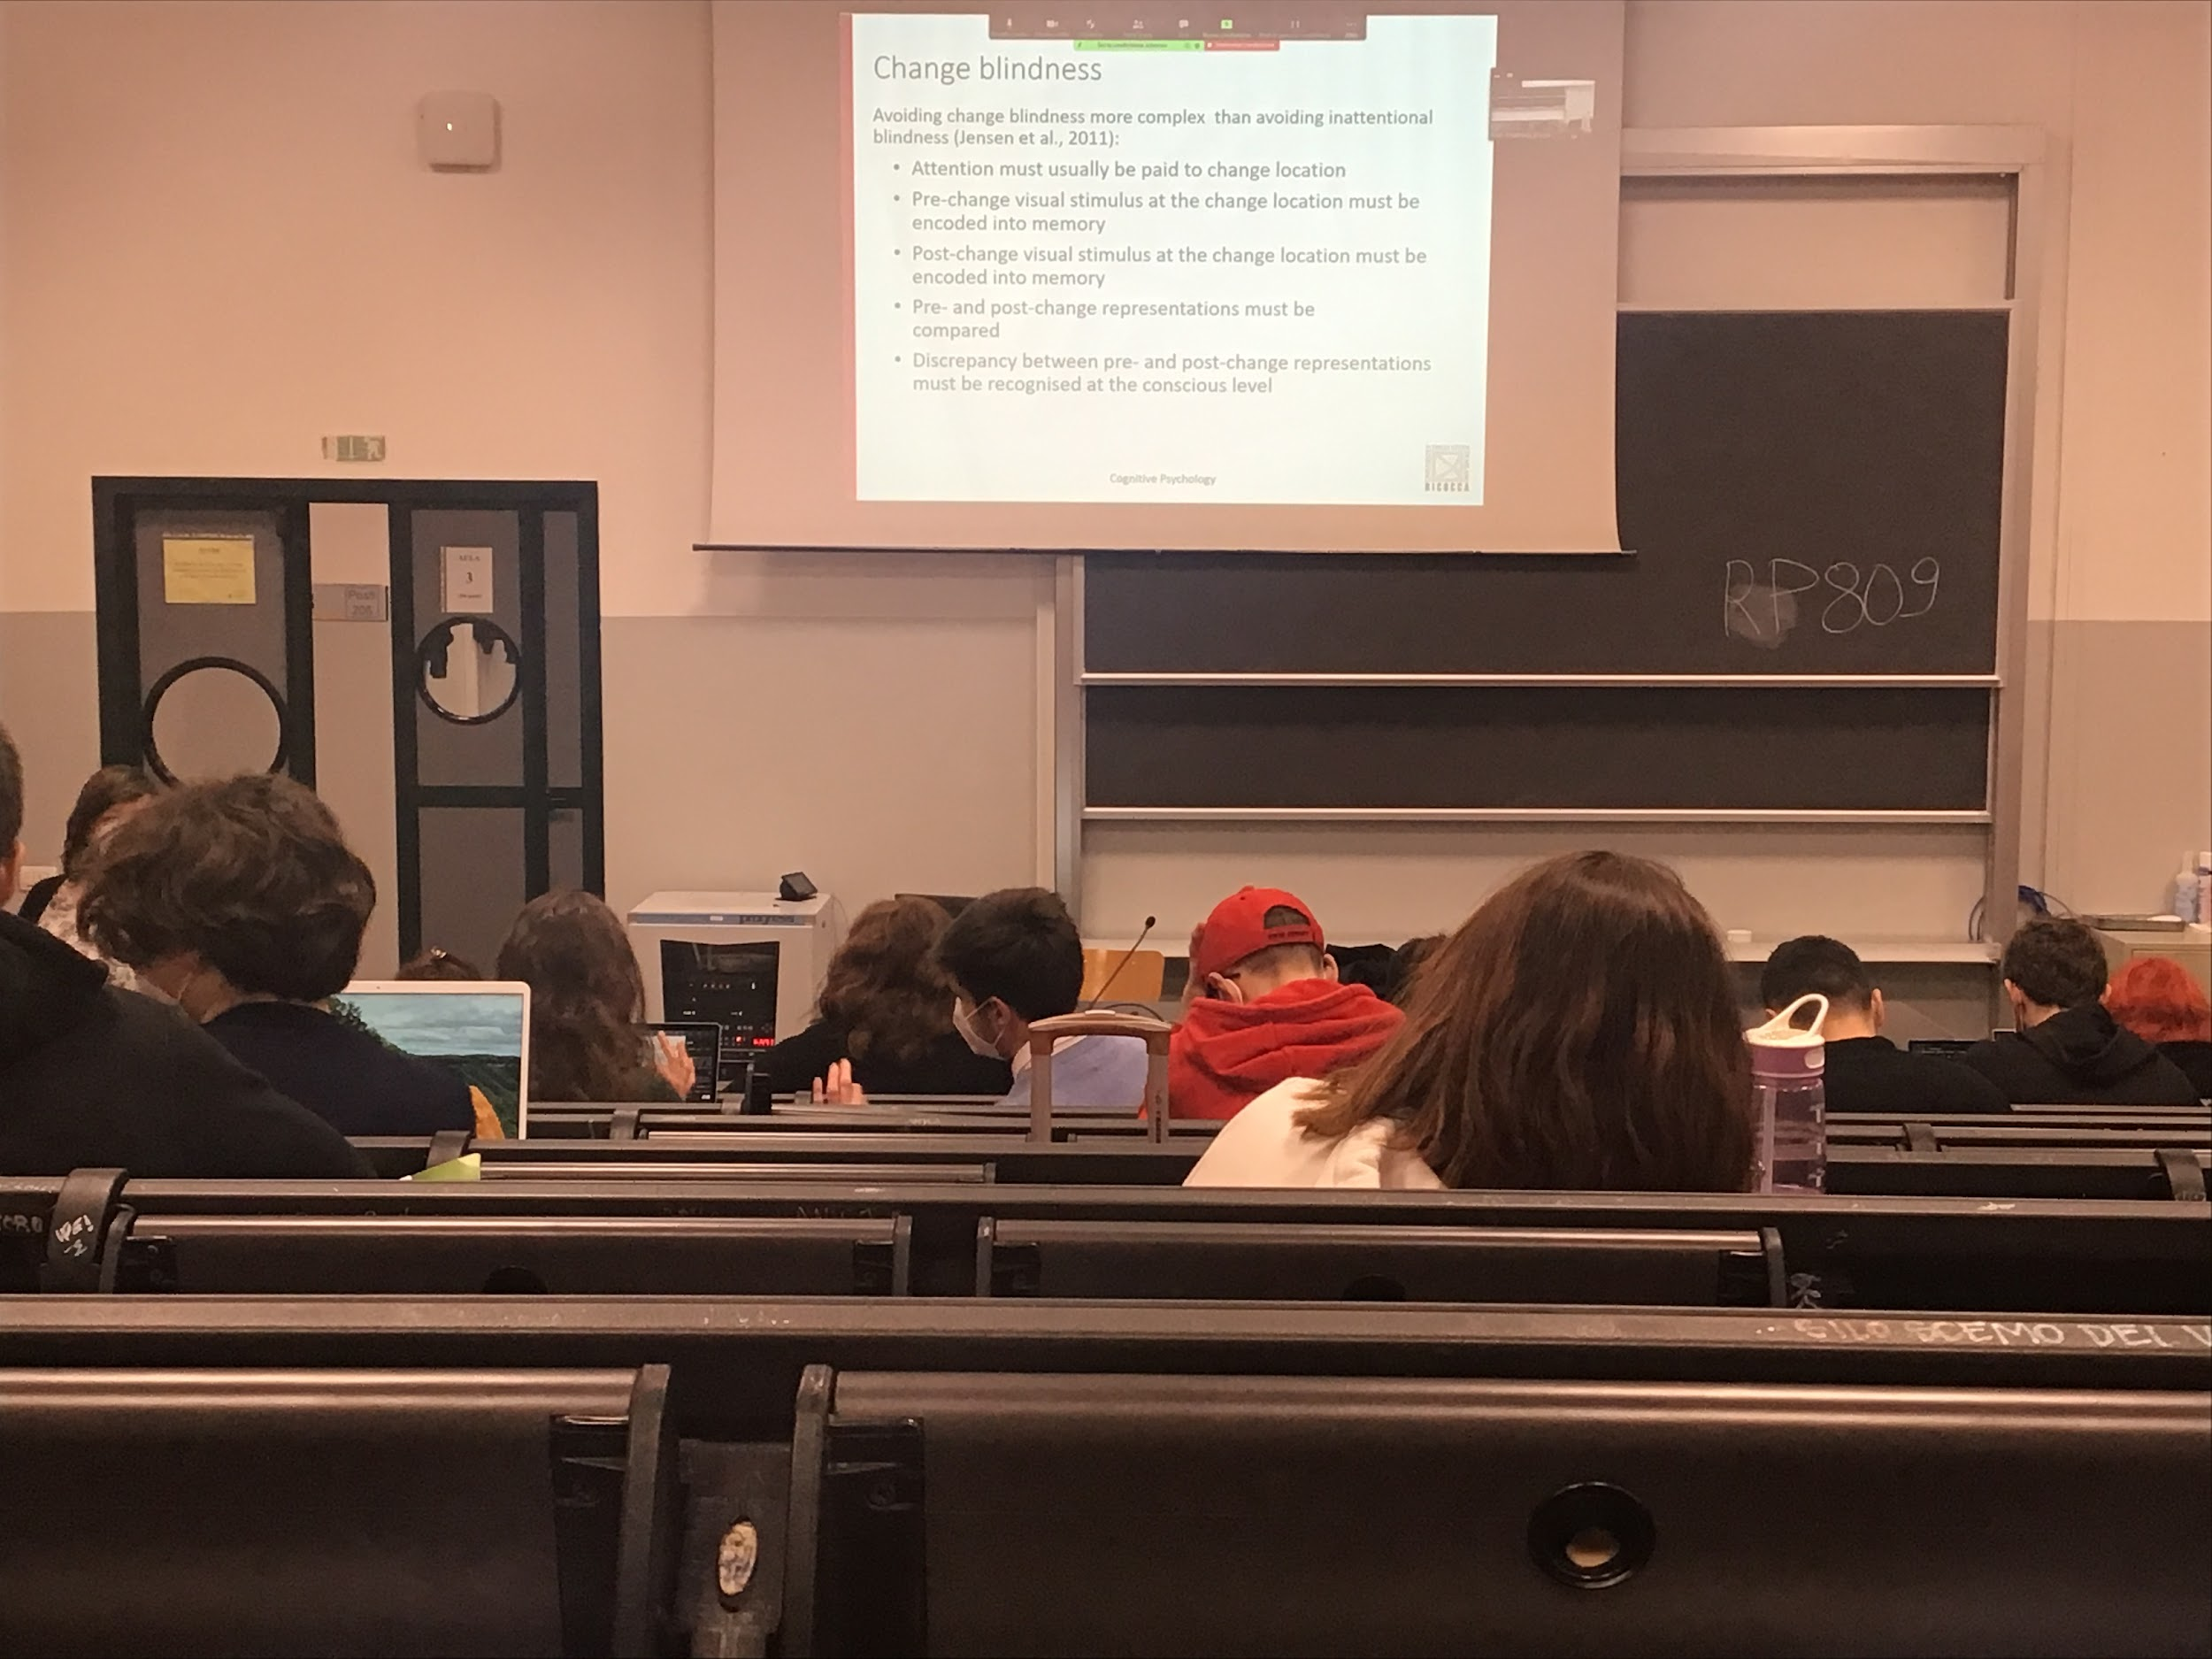

Experiment: two pictures and a white screen alternating with one difference

Once you see it you can’t unsee it, the fact you did it earlier or later doesn't depend on how good you are

The difference is in the centre of the visual field

If you remove the white screen you just see a plane with the motors blinking, you see right away the difference. With the white screen you are clearing the image in our eyes and everything start to be compute again

### Audio 2

Change blindness: Very difficult to avoid

It affect everybody, can not control it, easier to avoid in attentional blindness

Change blindness: attention to detect change we have to pay attention to that position, you have to code what was there before the change and compare

Change blindness and inattentional blindness is what magicians use

Experiment: cards tricks, select one card

The tricks work because I use inattentional damage, change all the carts

You were paying attention to only one cart and you were disattentence everything else

If I leave the cards for to long you might be undecided which one you want to pick and you will code two different cards

If instead of the figures I had the numbers, you will realise right away that all the cards were changed. Some kind of information you did code, the detail is coded only when you put attention

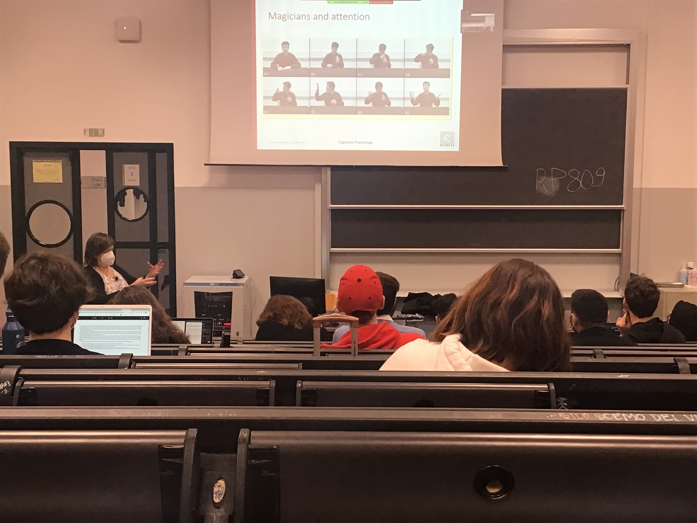

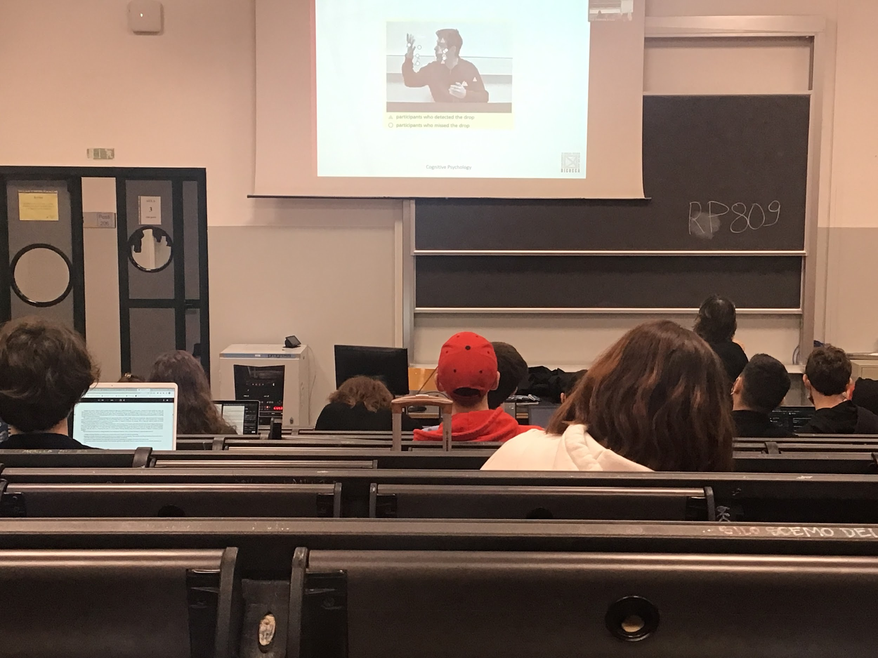

In this frame the lighter is in left hand and he drops it. When doing this movement people are looking at the other hand. Most of the people were looking at the right hand or the face and did not realise the trick

Where we position our attention we code more in detail perceptually the information about the stimulus

Attention can be separated from where you put your eyes, I can pay attention in the perfiery even if you are looking at something else

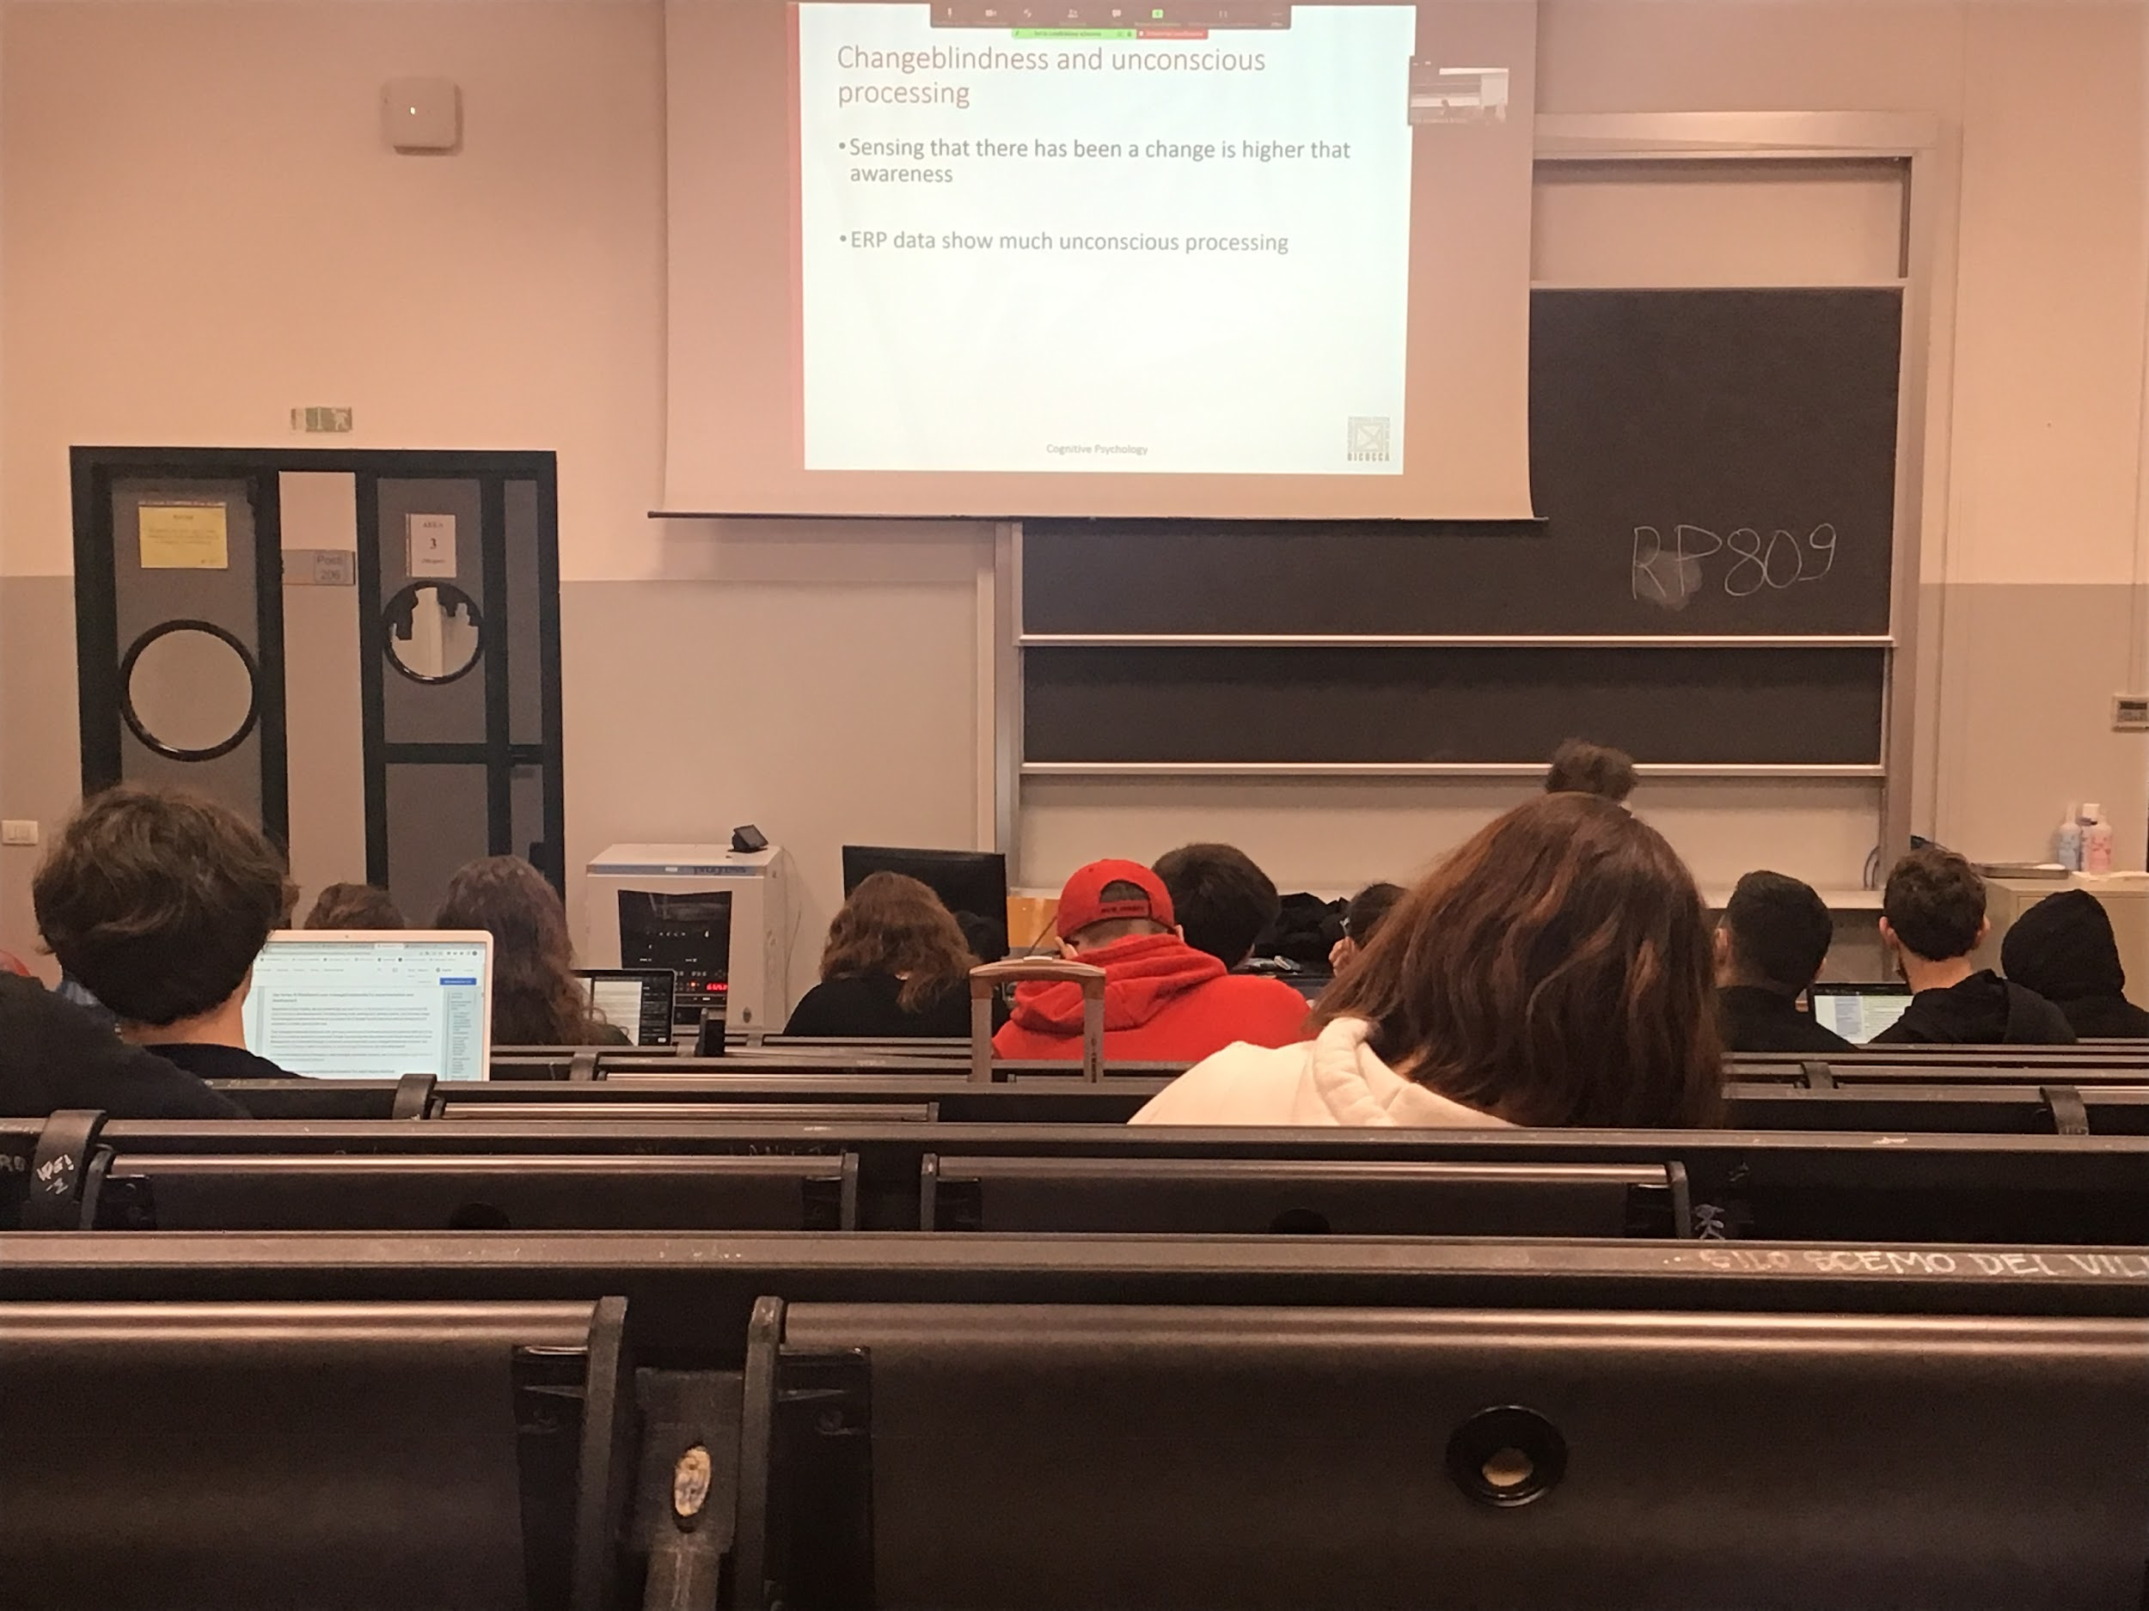

Change blindness does not mean that the change that you did not detect was not detected by the system, if you ask people to guess if something changed or not they are much better. Don’t know what changed but knows that something has definitely changed

There is some kind of unconscious processing

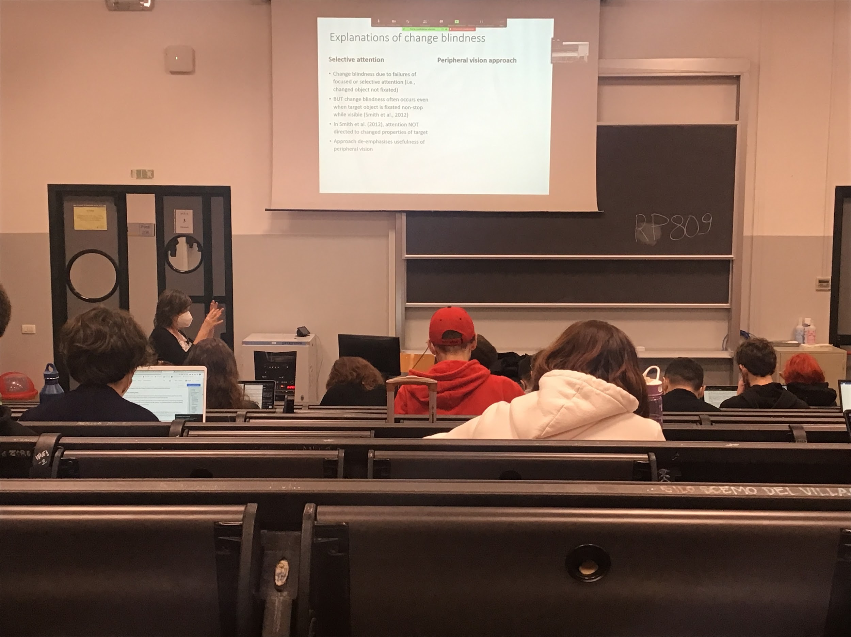

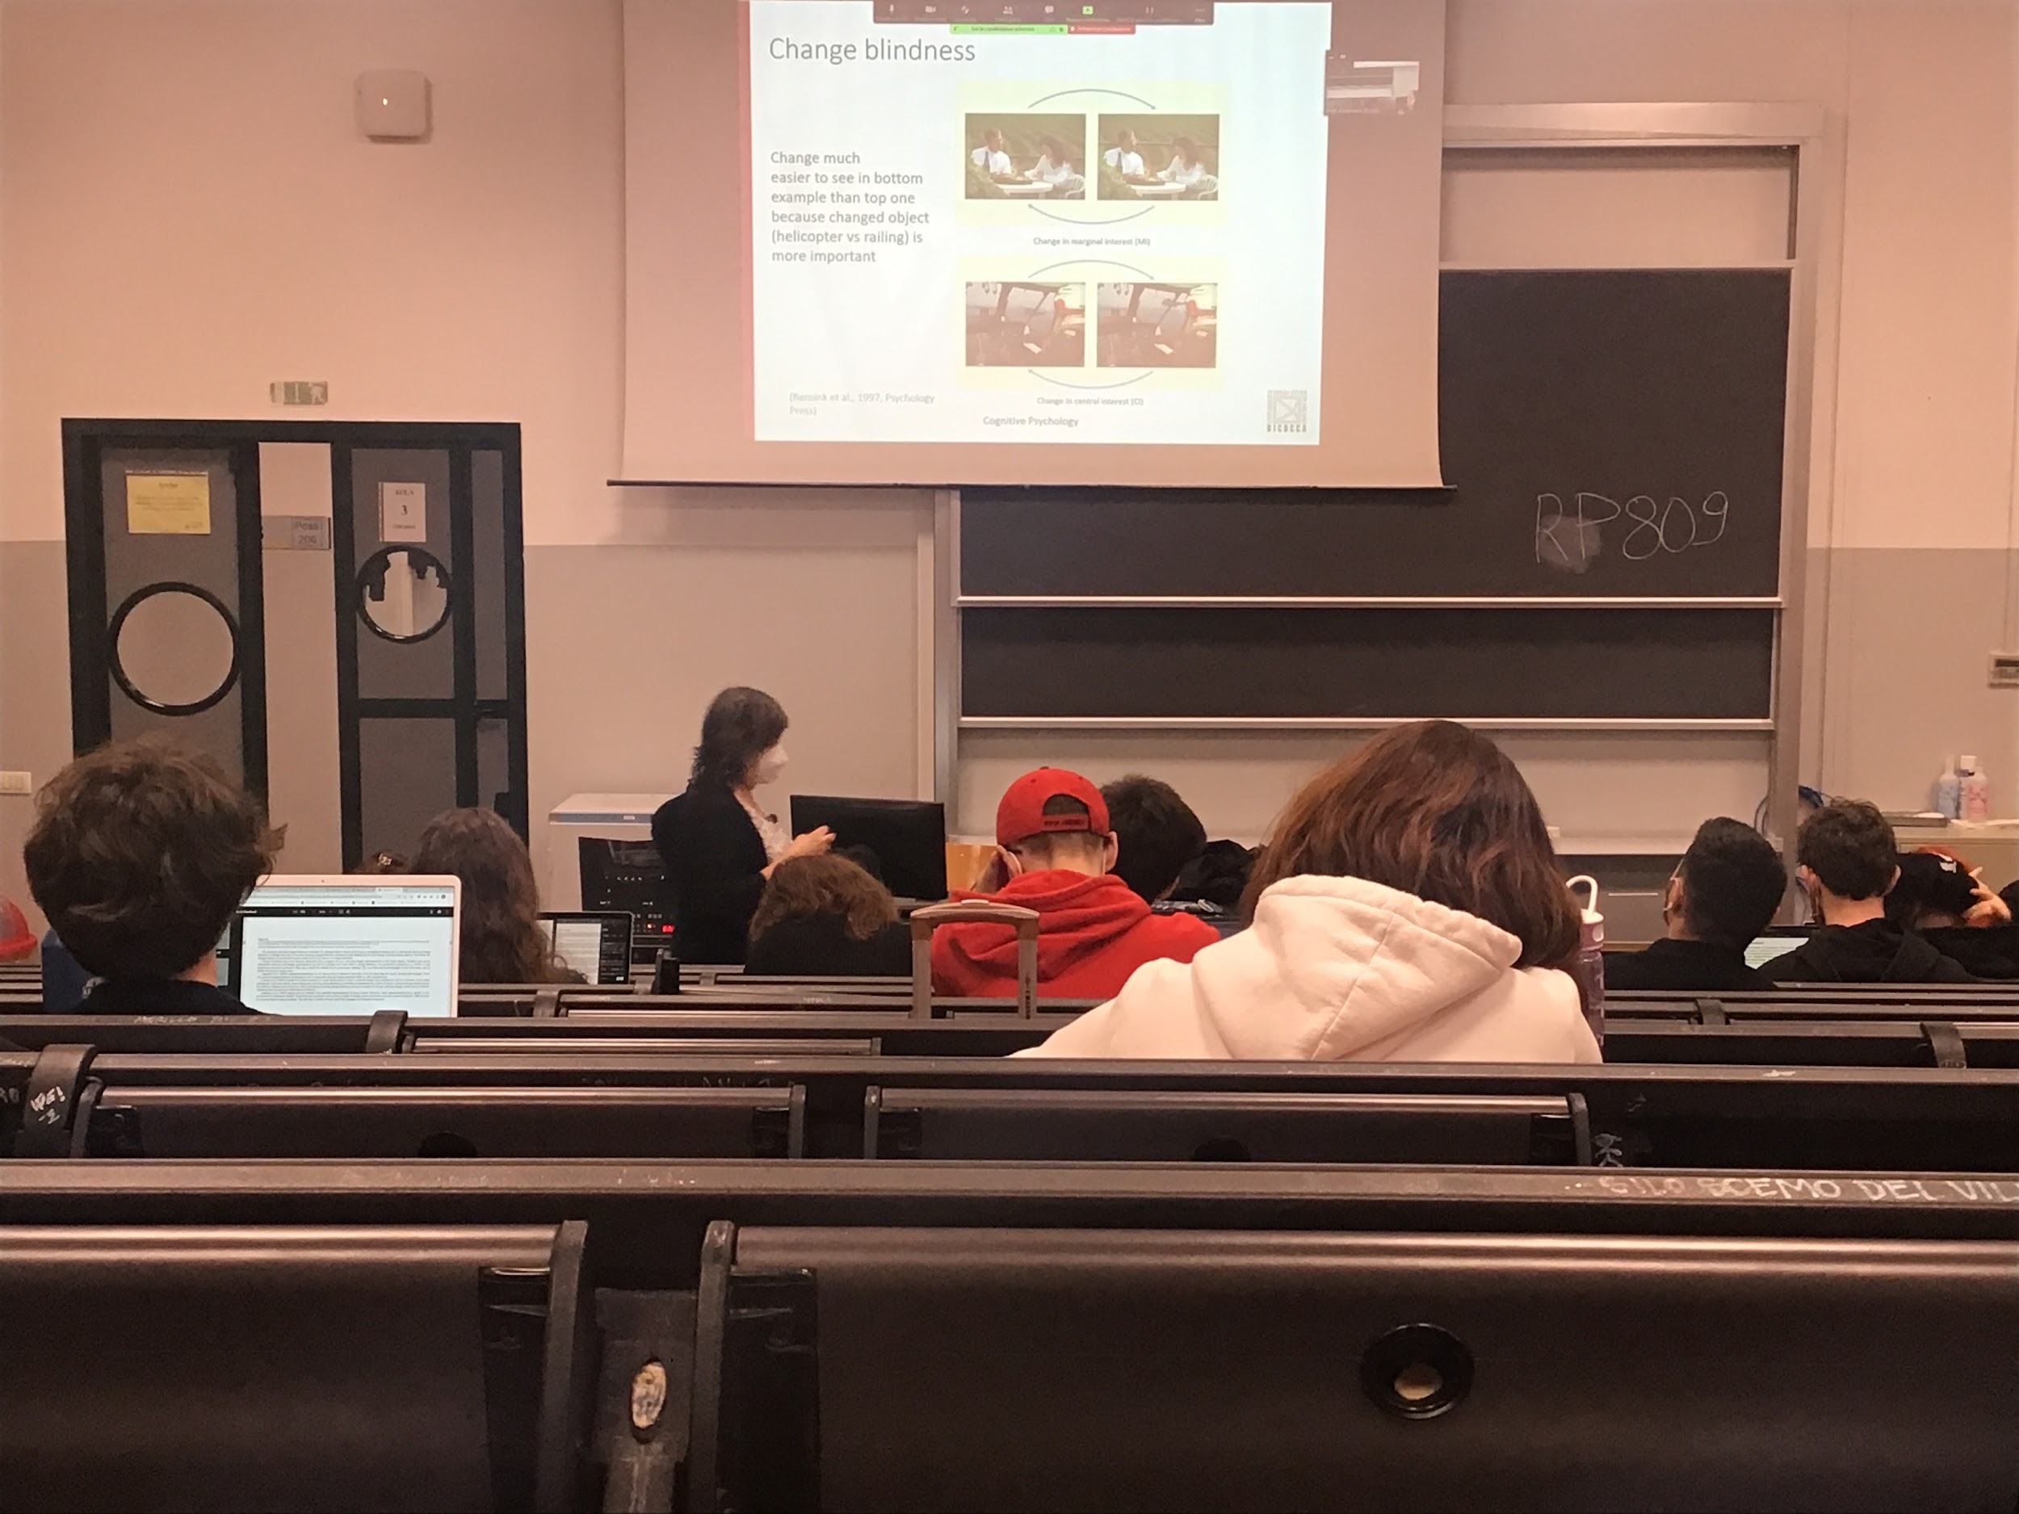

Sometimes even if the change happen exactly where you are looking you can not realise the change

We realise faster some changes in compare to others

First two pictures: change in the horizontal bar, takes people ages to find it. Change in marginal interest

Second two pictures: helicopter going up and down (same movement of the images before) but more easy to spot. Change in central interest

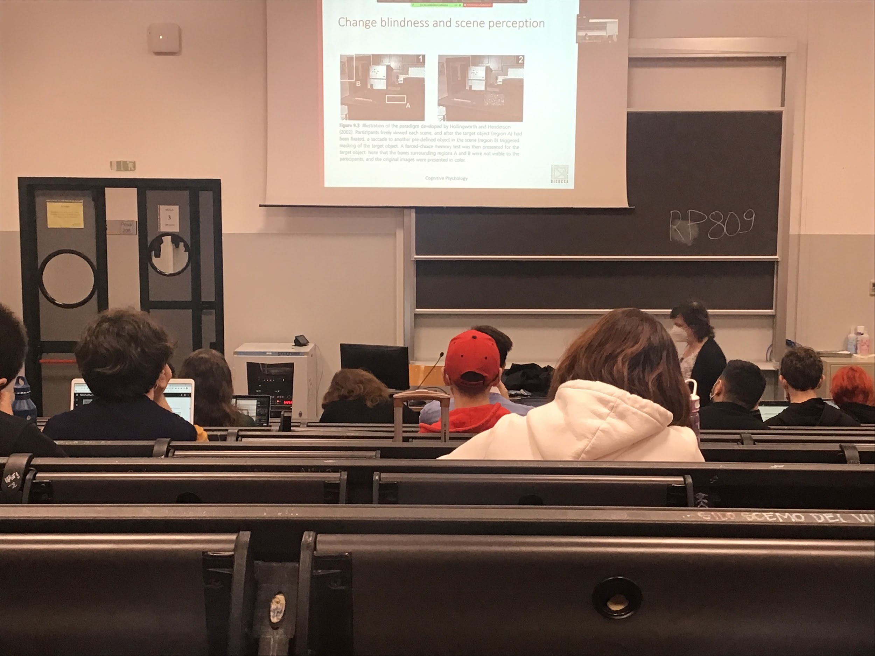

Look at one static image, after a while on the table appears an object, what I change is deciding when to make the object appearing depending on when the person was looking at

Why you moving from point A to point B in the image I make the change

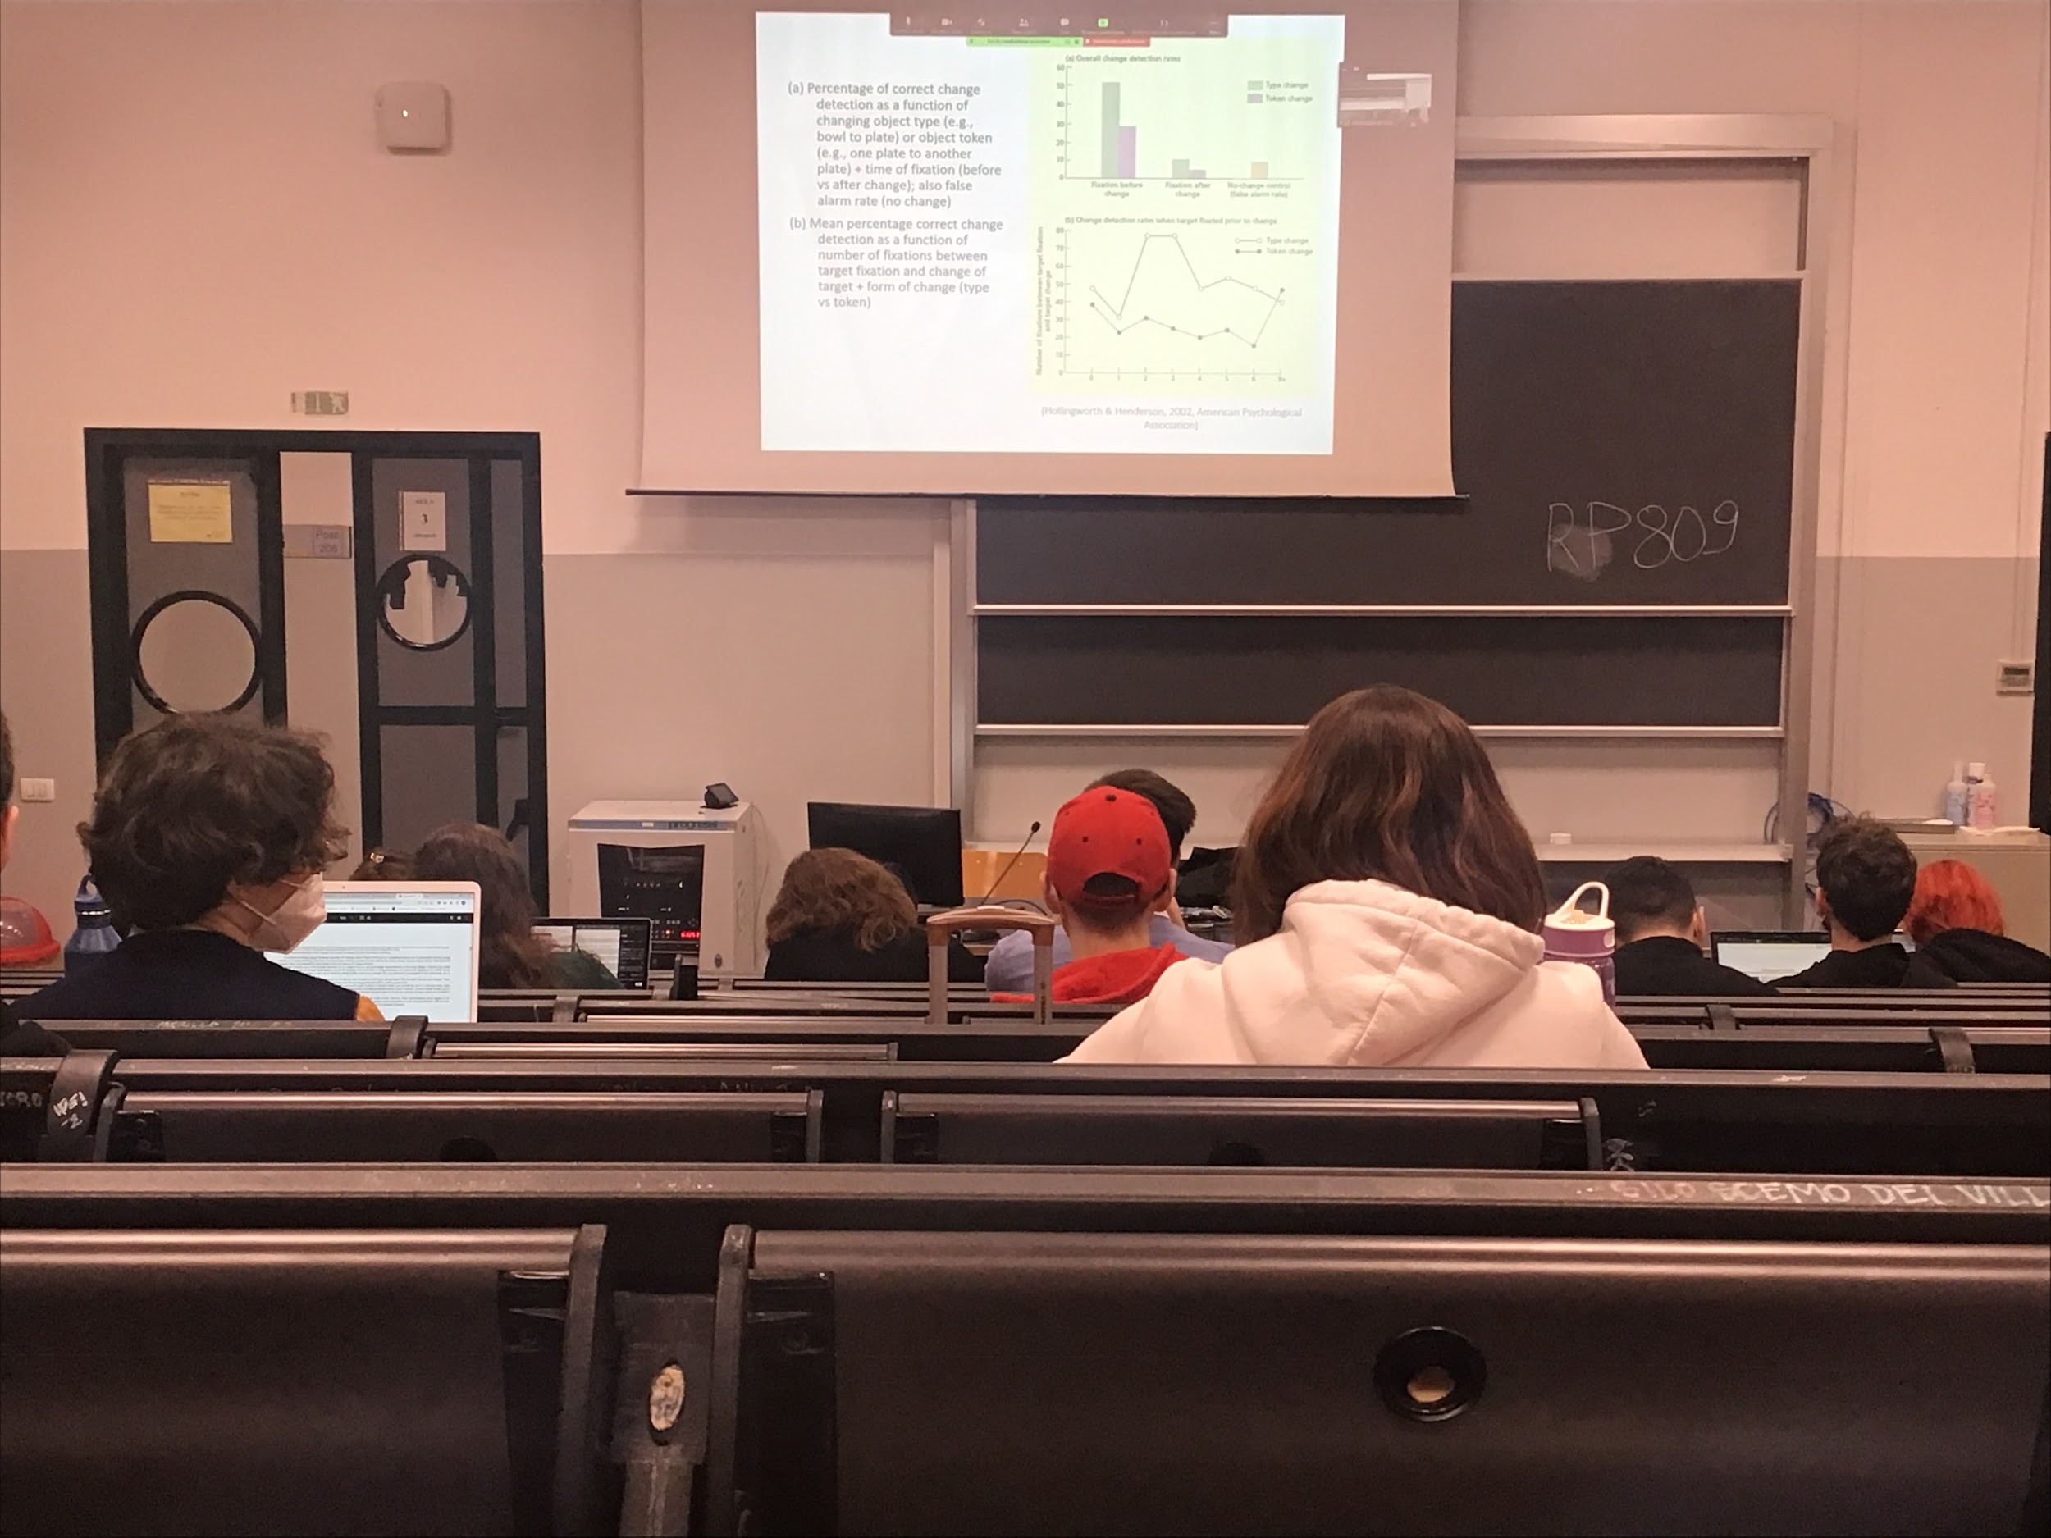

The ability to detect change depends on where you were looking at before the change happened. If you were looking at the object before the change you realise the change

At each movement we get a better general idea of the image, we code characteristic more in details

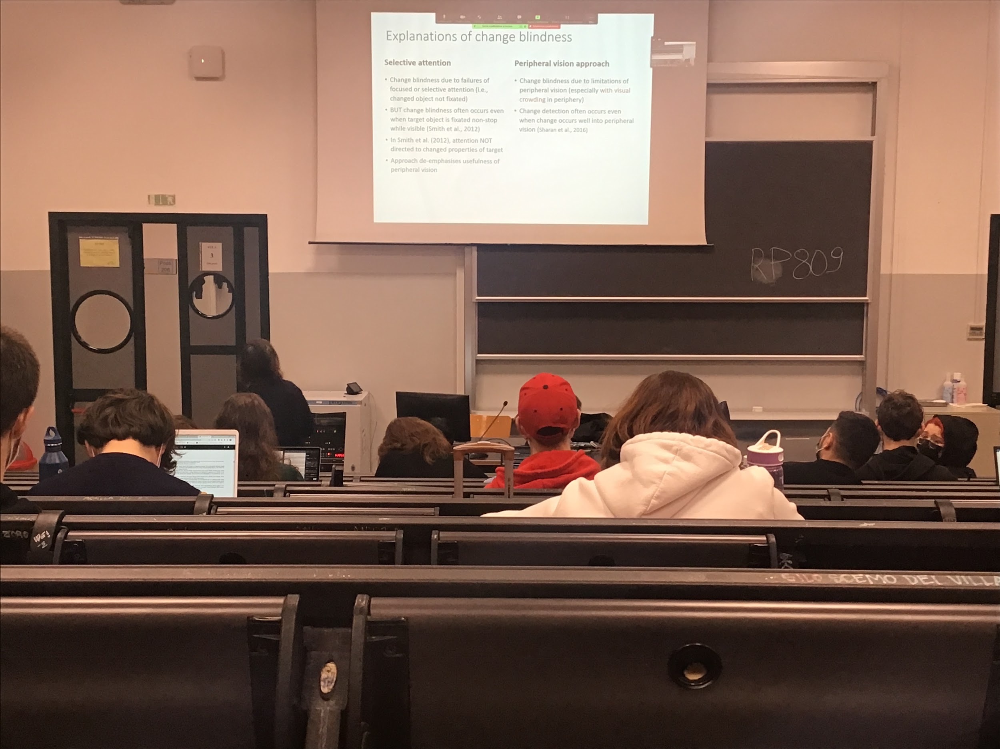

When you look at one position all the information in the periphery are not coded

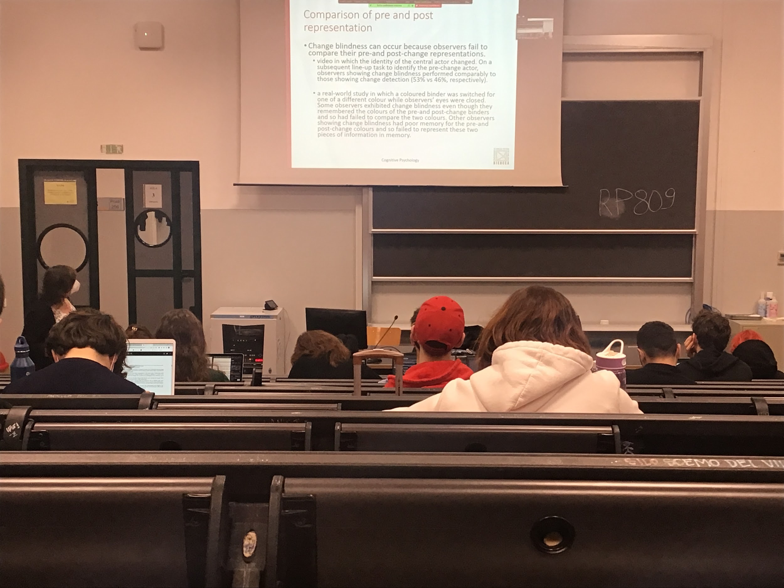

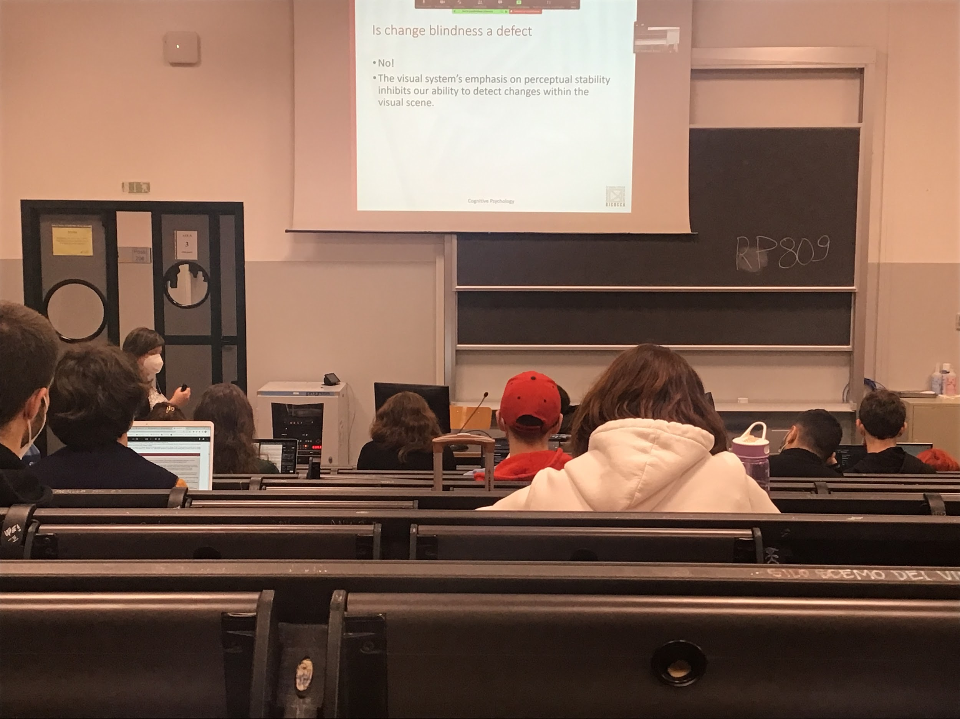

Change blindness mostly occurs because we compare the pre and post representation

If in a theatre after a while an actor change we don’t realise it, but if we have to choose which one was the first one we are good

We coded the difference but we did not do the comparison

The system has develop to code information that stays stable during time, more important than detect some strange changes that psychological detect artificially in a lab

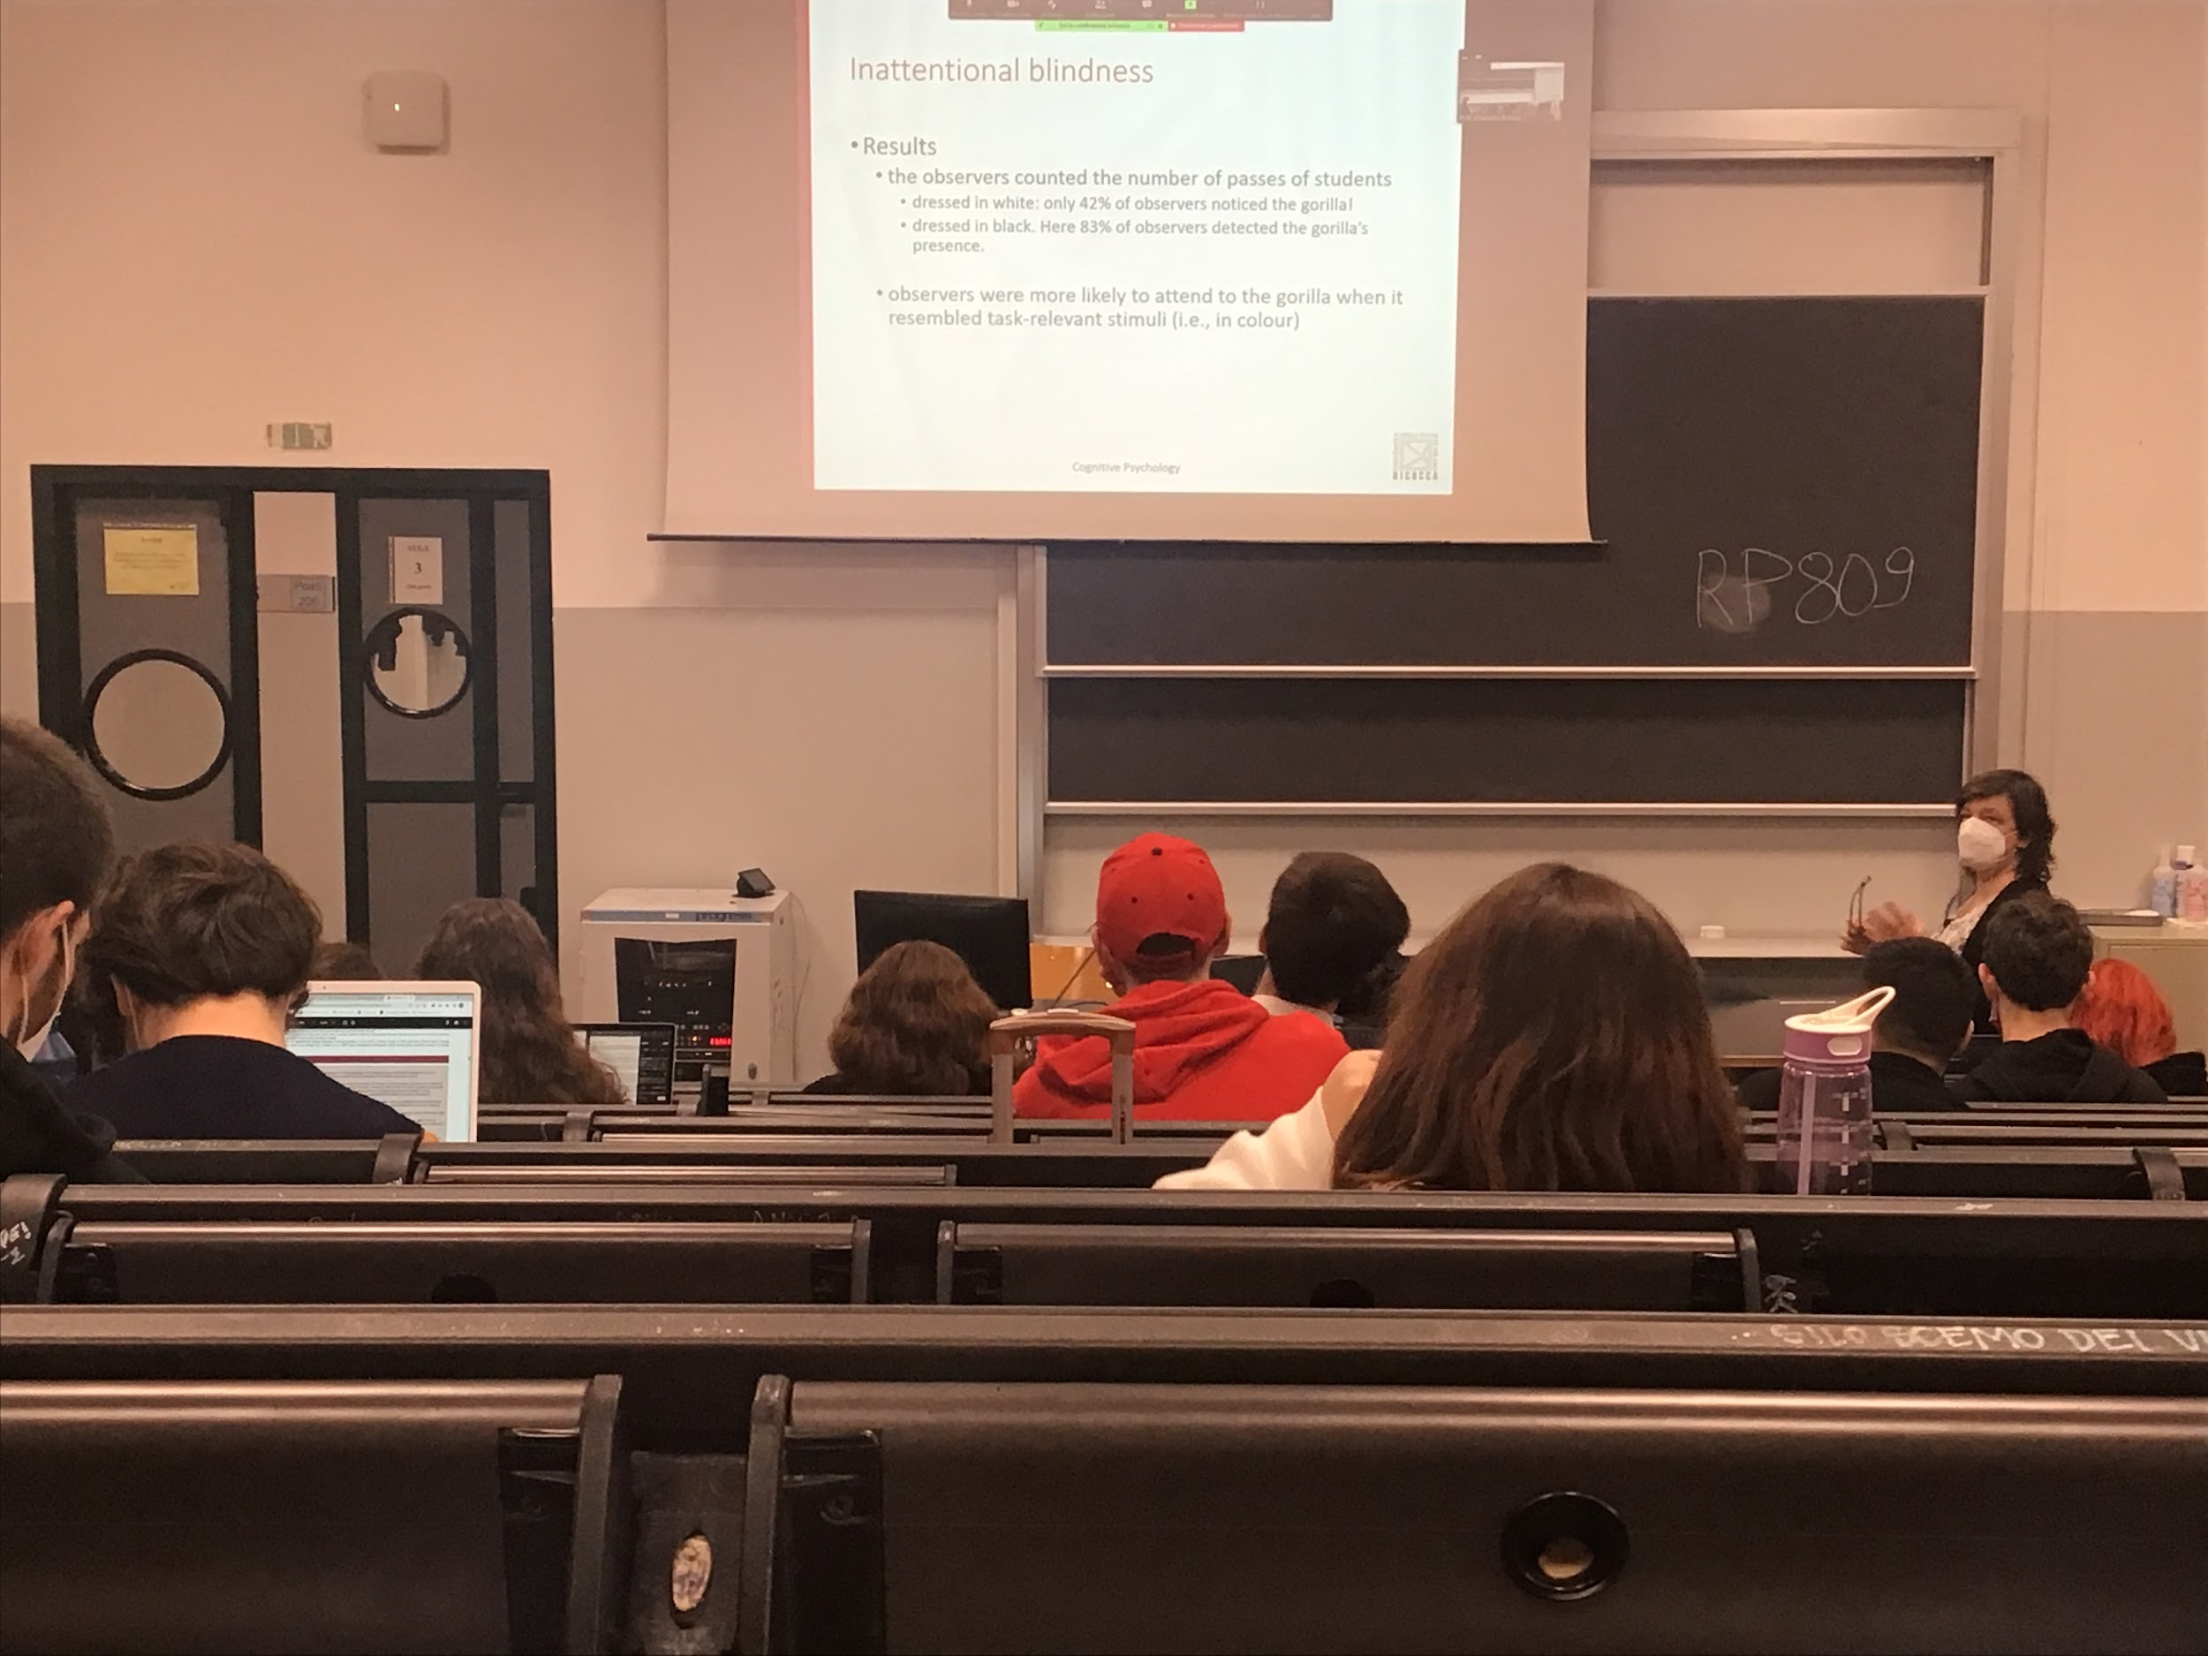

Video of basketball player with white and black t-shirt

Some people did not see the gorilla

Inattentional blindness: the fact you are paying attention at something and you don’t see the gorilla. 42% detected the gorilla

If you ask instead to count the passes of the guys in black, same colour of the gorilla, many more detect it

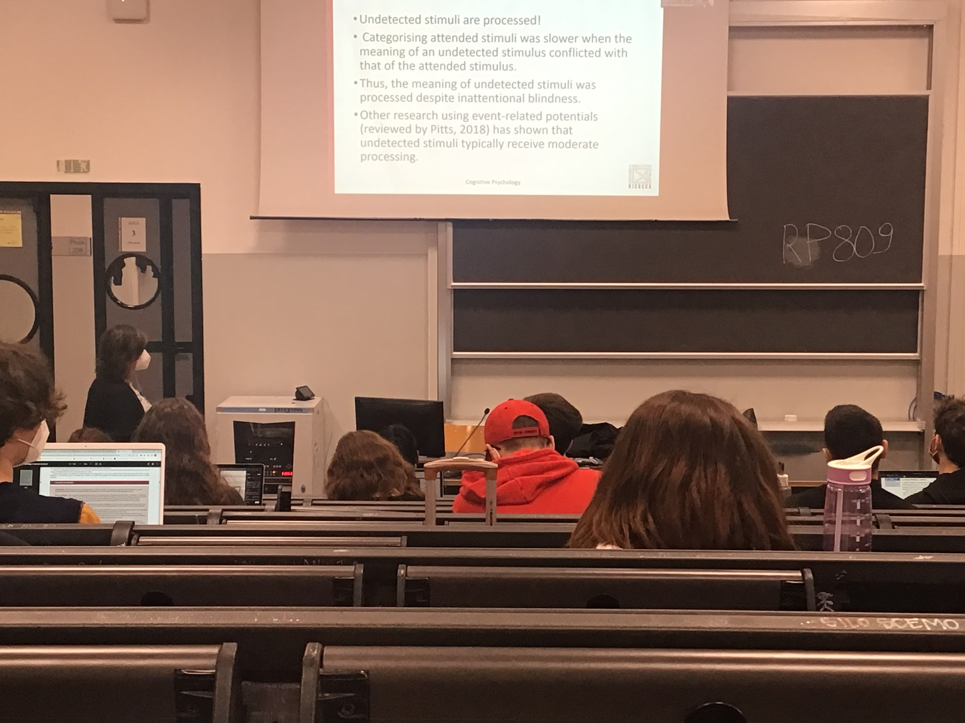

Experiment: indications and doorstep

50% of people did not realise the change

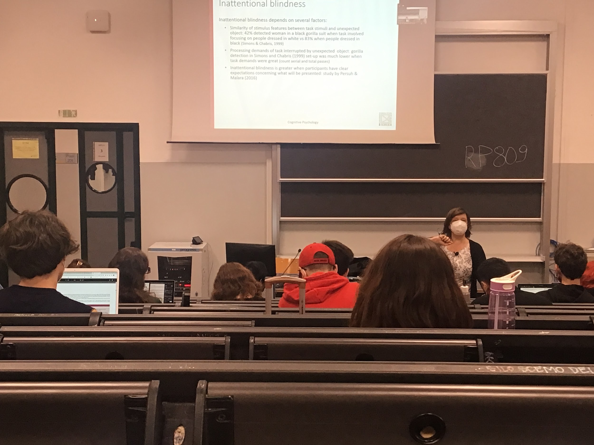

Inattentional blindness depends on several factors, if I make the task more complicated, than you detect even less the gorilla

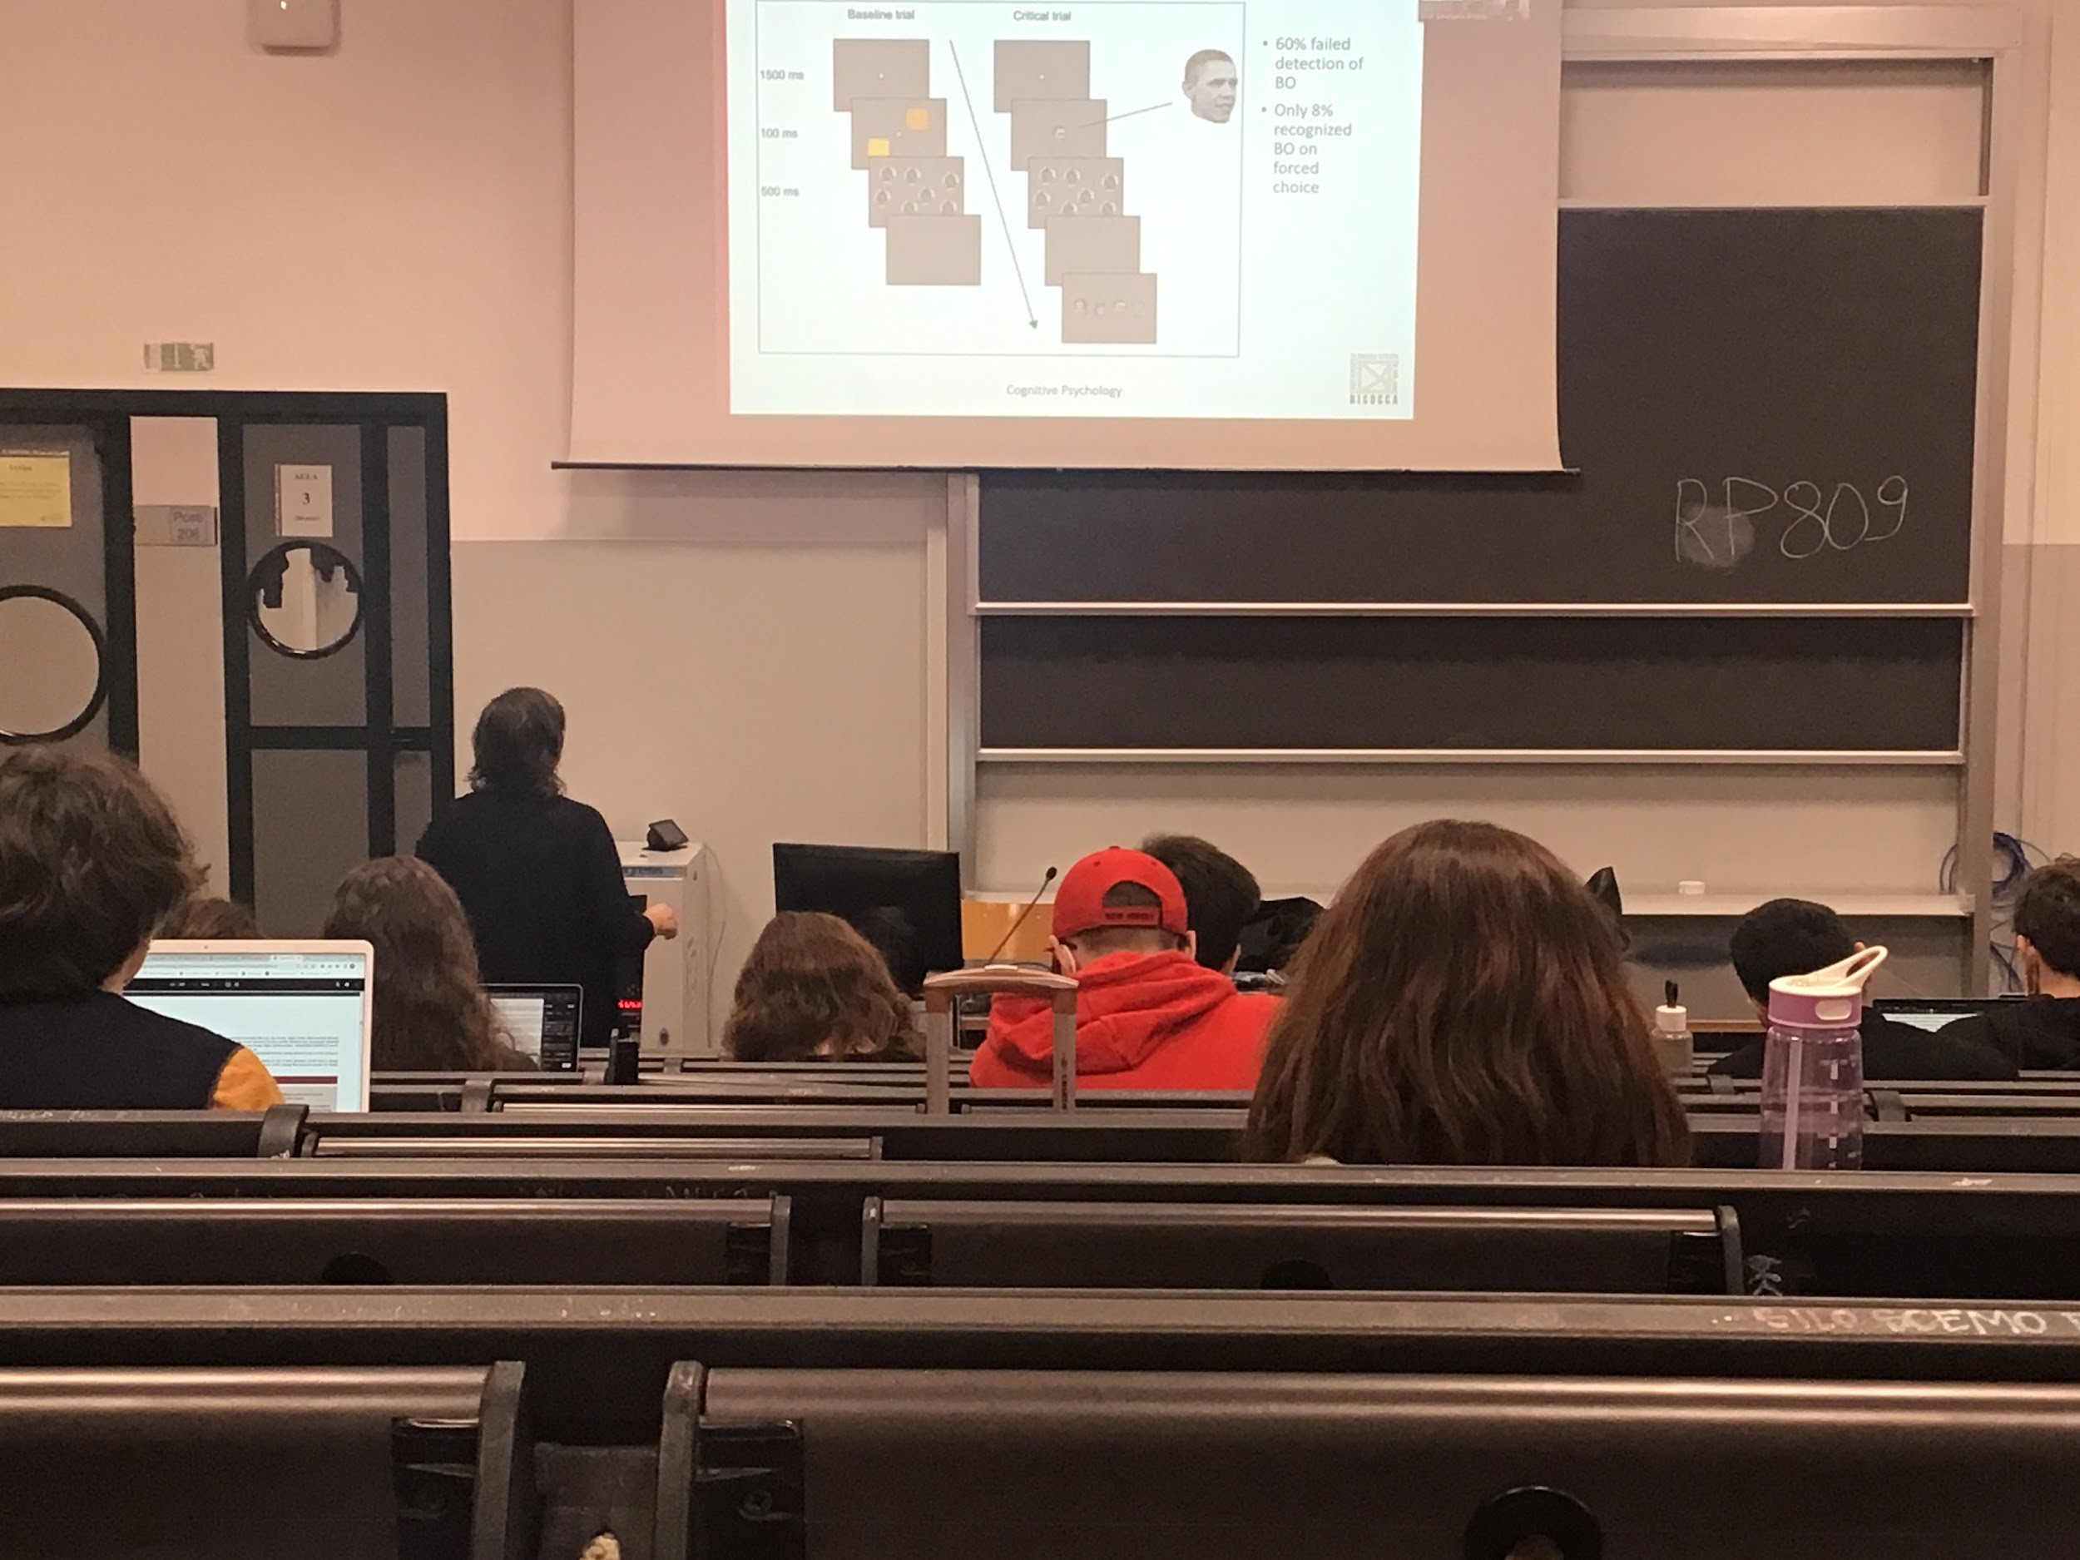

Experiment

Even if I present an object exactly where you are looking at you don’t see it

There is a fixed point and you have to look at it, I present two squares peripherally (keep looking at the centre) and you have to judge the difference of colour. Than I make a mask, at a certain point after 20 trials you present in the centre the face of Obama instead of the squares.

60% didn’t realise that there was a face exactly in the centre

After the presentation I show 4 faces only 8% guesses that was Obama, my change would be 25%, but were sure that for them there was no possible way that they would not detect the president, lower obama probability

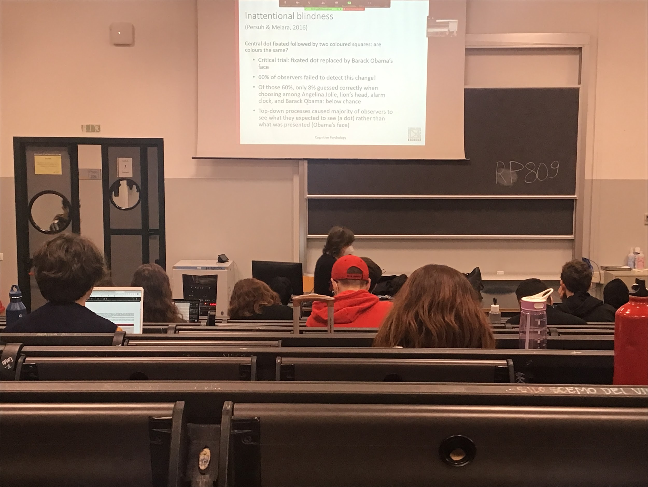

People believed that the dot was there all time

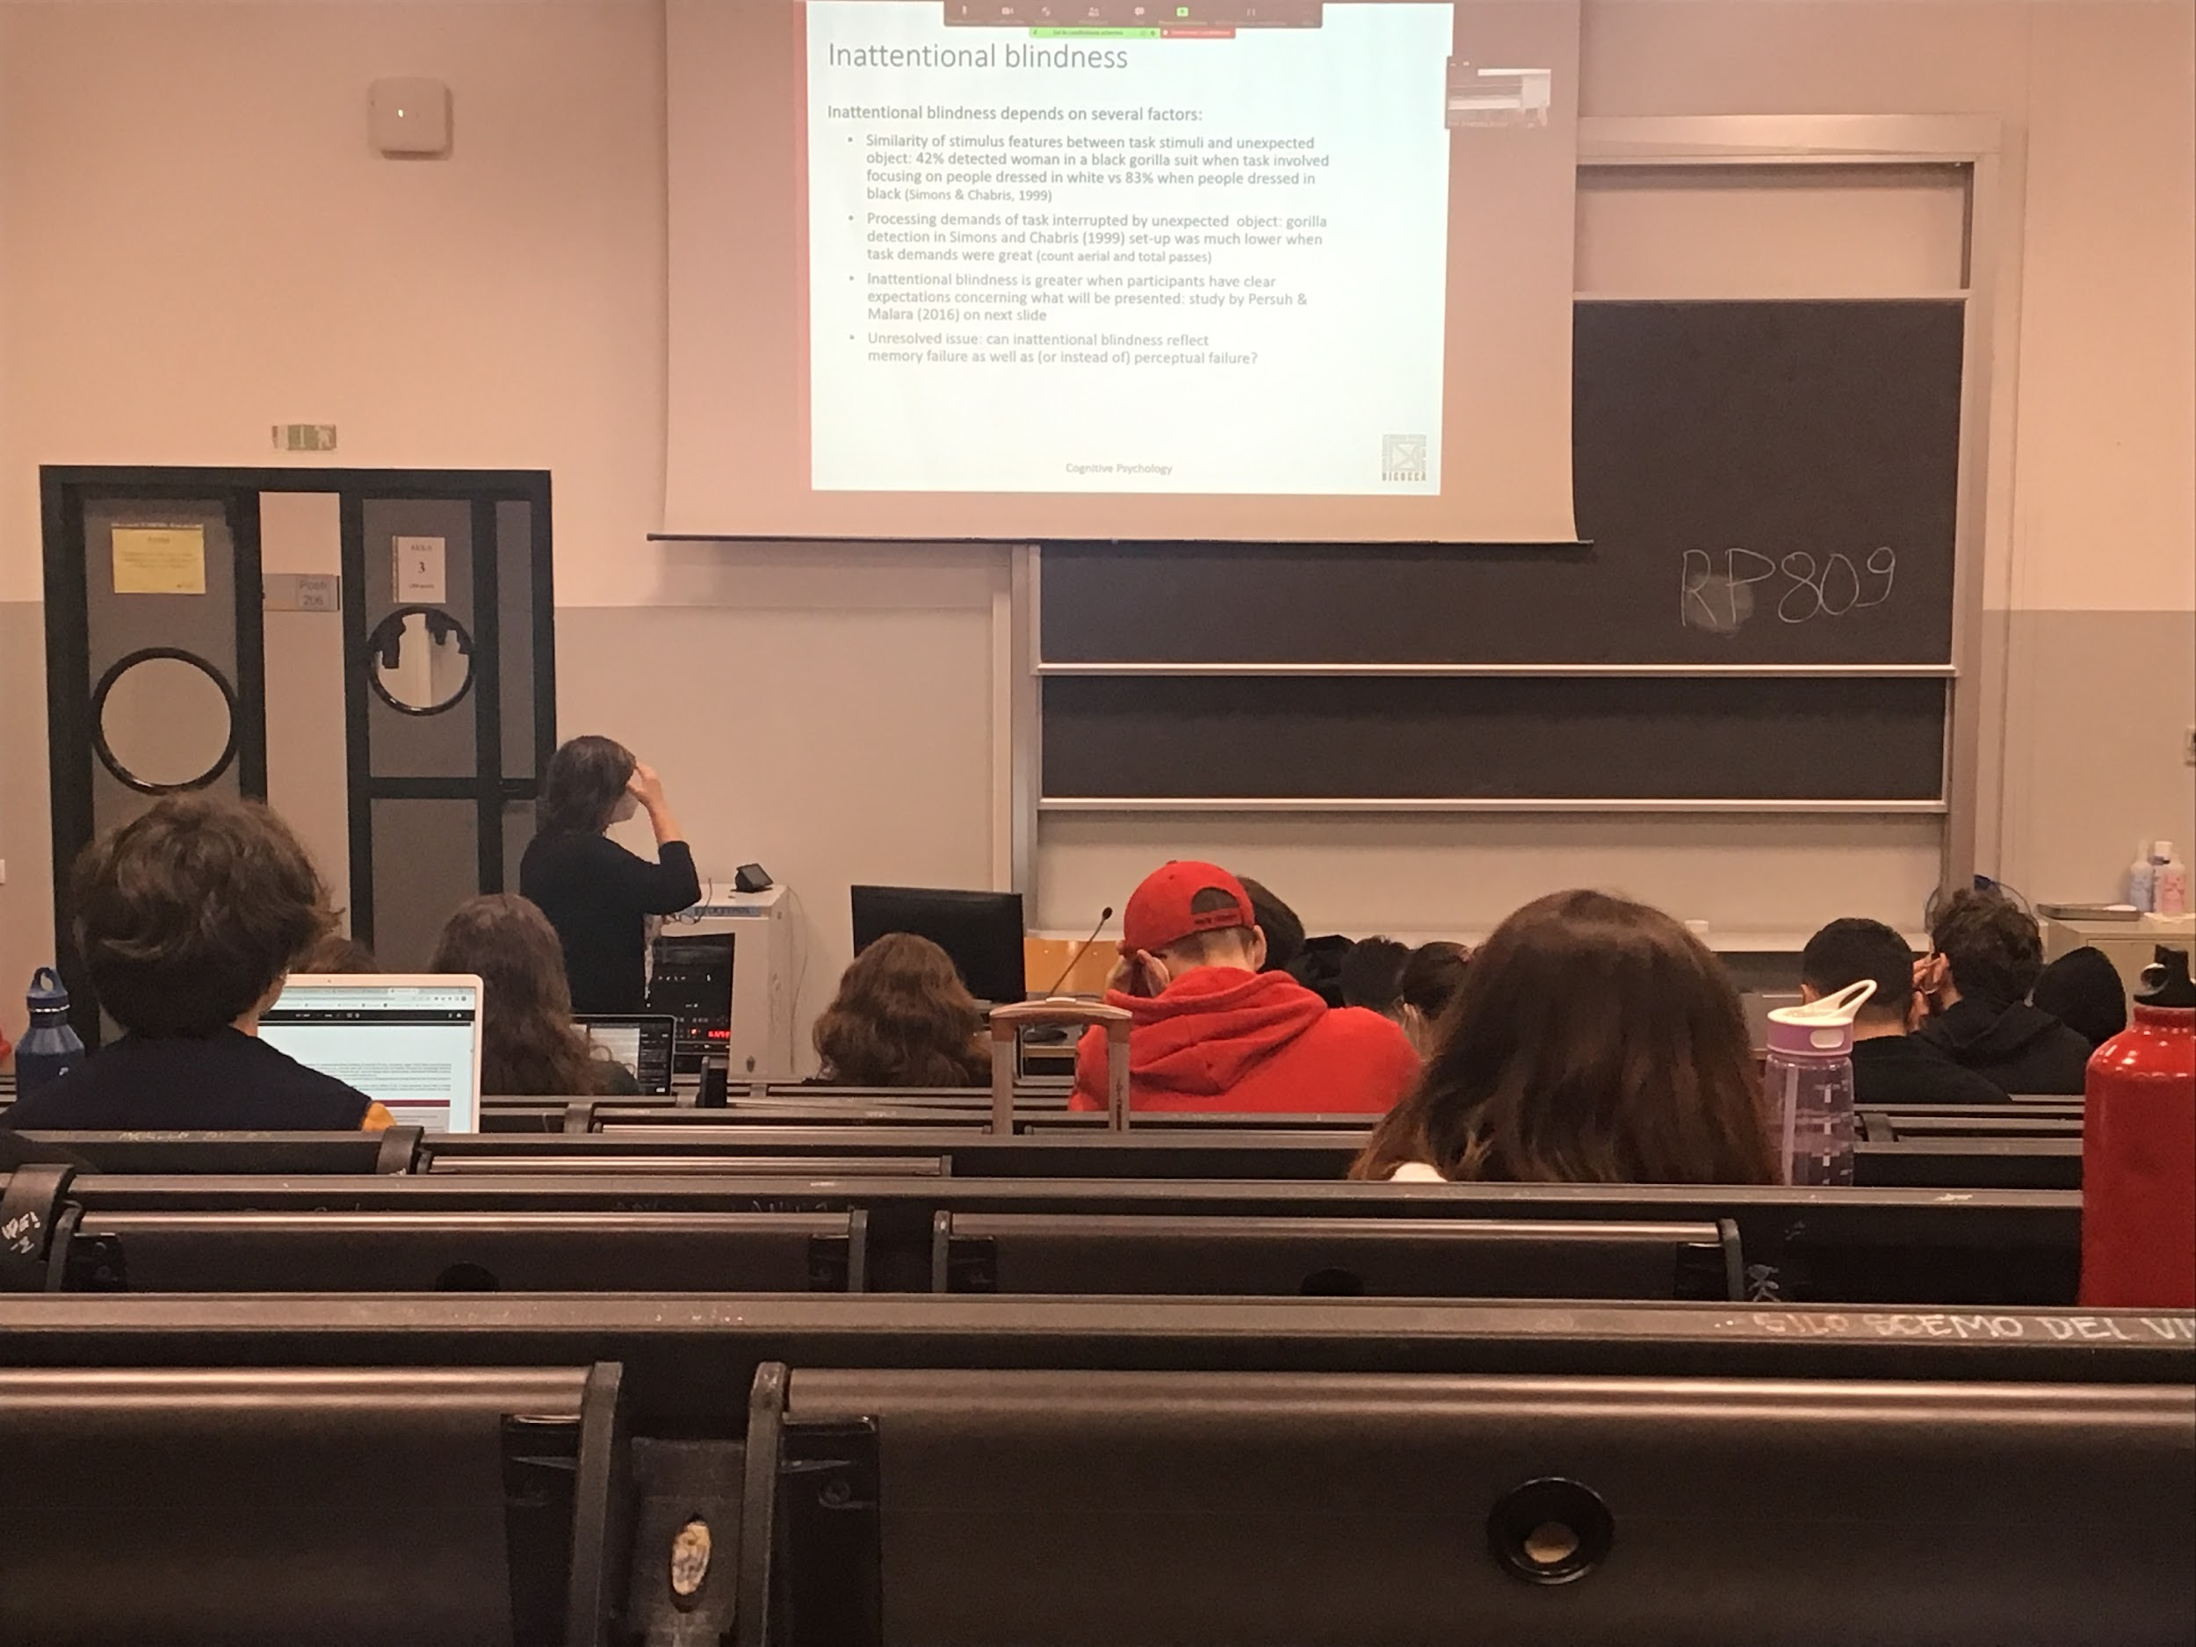

**COGNITIVE PSYCHOLOGY**

**CH.5 attention and performance**

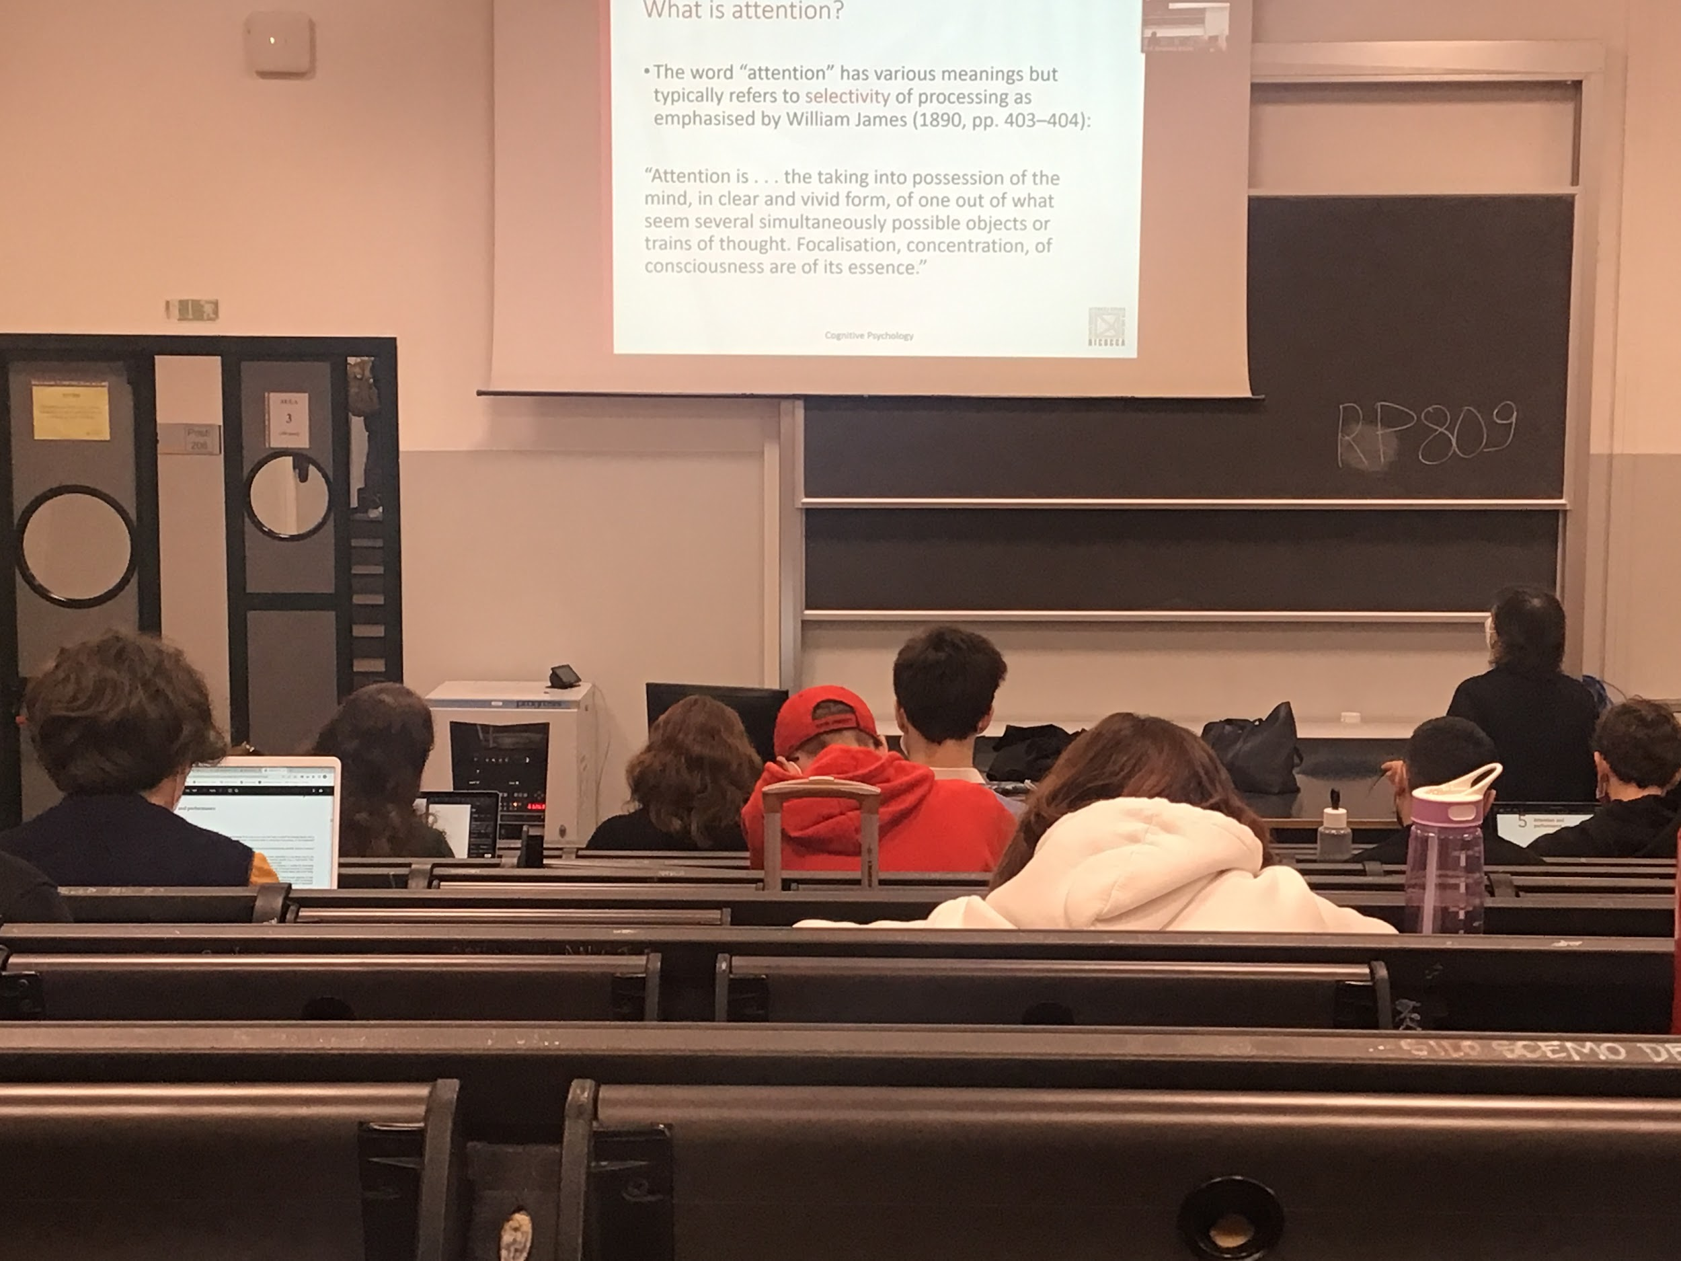

Attention means a lot of different things

Attention connect to selectivity: one example is attention to something, select that type of information, take out information out from the rest we are not interested

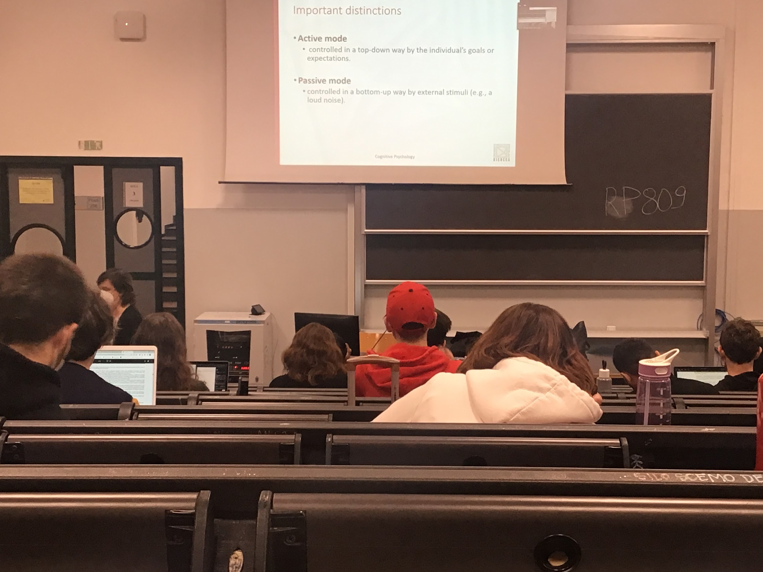

We select one path

3 important distinction in attention

* Activity mode: *look at this image and put attention on the top left corner*, force your attention to a given position, or *pay attention to what you hear, what comes from the left…* is an active mode, you can decide what to do
* Passive mode: some types of external stimuli automatically control our attention, a big sound… movement also (move one hand to attract attention). Enable us to identify changes that can be important for our behaviour

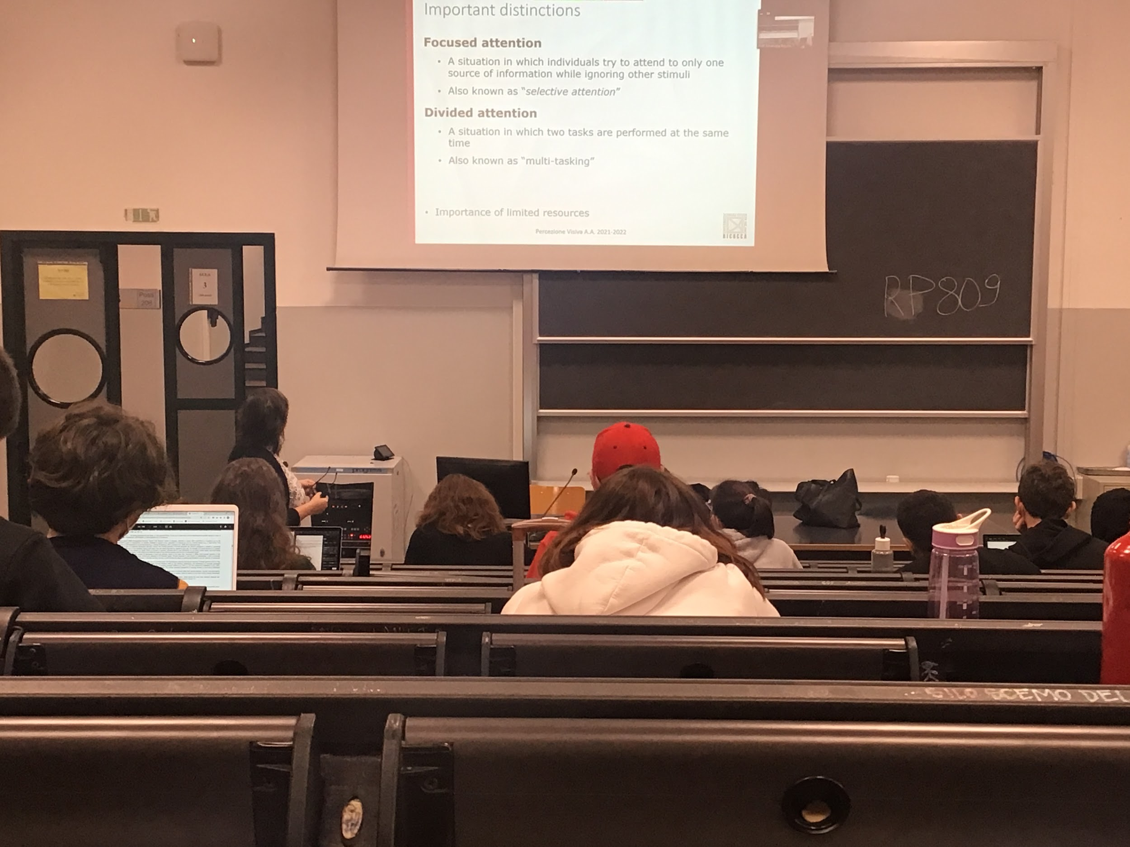

Attention is needed, we have limited resources so we have to select what to focus on,

* **Focused attention**: we can focus our attention, concentrate our resources on something. *Look at the top left*
* **Divided attention**: divide attention in different things, listening to a person re-formulate what she says and write that down. Distribute attention on different topics at the same time. Multitasking

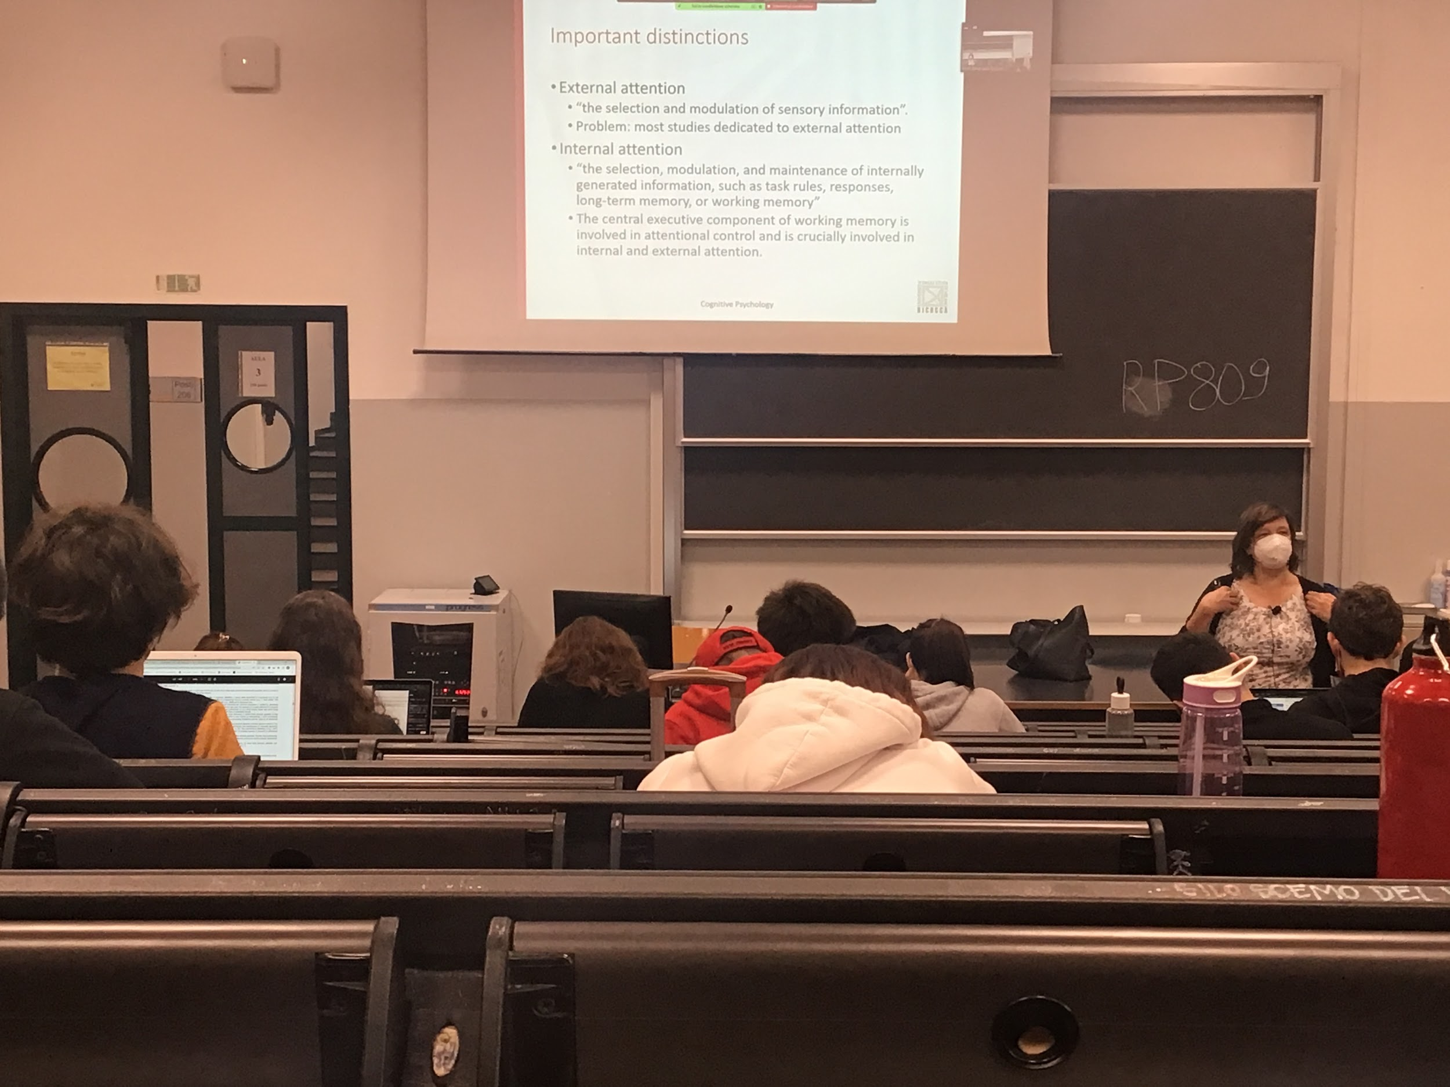

* **External**: attention to something that happen the environment, coming in from different senses
* **Internal**: pay attention to our internal feeling, our thoughts, needed to select what we are reasoning on in any given point

The problem with cognitive psychology is that most of the time we have a lot of experiment on external attention but few in internal attention